

QUEENSLAND INDEPENDENT CAT COUNCIL INC.

Executive Committee for 2008

President: Bev Wiles
Email: qiccpresident@gmail.com

Vice-President: Debbie Bright
Email: allthebrightcats@hotmail.com

Treasurer: Chris Taylor
Email: ancris@bigpond.com

Secretary: Sherin Henriksen
Email: rocketzxr@hotmail.com

Membership Officer: Les Pitkin
Email:lespitkin@primusonline.com.au

Committee Members:
Ann Ward
Dee Wilson
Rodney McGregor

Registrars:
Group 1 & 4
Lynn Nielsen
Email: stylynkennels01@dodo.com.au

Group 2 & 3
Dee Wilson
Email: ilikecornchips@hotmail.com

All Correspondence to
QICC Inc Secretary
1 Bullock Street
Toowoomba 4350
Tel: (07) 46340078

If you wish to submit articles please contact QICC secretary. Make sure you ask for permission from the author of the articles.
Welcome
We would like to wish a warm welcome to all our new members and thank them for choosing QICC (Inc). We look forward to meeting as many of you as we can at our shows and open meetings.
The Management Committee of QICC (Inc)

EVENTS LIST

COY Dinner
This year’s Cat of Year Dinner will be held on 29th November at Yeronga Australian Football Club, Cansdale Street, Yeronga
For further information, please contact
Sherin Henriksen Tel:0746340078

Show Manager’s Course
There will be a Show Manager’s Course held on Saturday 12th December, 2008. For expressions of interest, please contact Julie Walker on
(07) 3385 6183 mob: 0431 150 934
email: vanstar1@bigpond.com

Stewards and Ring Clerk’s Course
Les Pitkin will be arranging a stewards and ring clerk’s course early next year. If interested please contact him on (07) 38072659
email: lespitkin@primusonline.com.au

Hinterland All Breed Cat Club
Fundraising Dinner
The HACC is organising a fundraising BBQ to help raise funds to bring out Connie Webb (TICA Judge) from United States. We would like to cordially invite all QICC Inc members who would like to attend.
Date: 31st December 2008
Time: 4.30pm
Venue: 26-28 Enkleman Road, Yatala
Cost: $20 per person
RSVP Les Pitkin by Wed, 17th December
Tel: (07) 38072659
Bring Your Own Alcohol
Numbers permitting

NEWSLETTER

November 2008

From the Registration Committee

Dear QICC members of Groups 1, 2, 3 and 4.

If it is at all possible, the registrars would very much appreciate if you could keep all your kitten registrations, higher status, and transfers up to date. Please send these in as they become available, rather than sending in a big lot in one go.

We promise you all that we will endeavour to get your registrations out in the return mail, or at least ASAP, but this may not be possible during the peak breeding season, especially if they are received all around the same time.

Regards
Dee Wilson on behalf of the Registration Committee

Group 1 & 4
Lynn Neilsen
50 Tibrogargan Drive,
Beerburrum 4517
(07) 5496 0054
stylynkennels01@dodo.com.au
Group 2,3
Dee Wilson
27 Andrew St
Capalaba 4157
07 3245 5764
ilikecornchips@hotmail.com

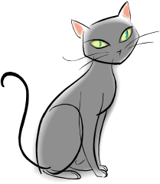

Innotek has introduced new fencing for cats. If interested please go to
http://www.innotek.net/

Membership Officer Report

I would like to welcome all new members that have joined QICC Inc.

A reminder that all membership are due in Jan 2009.
I would also like to welcome Christine Clewley an all breed judge to QICC Inc.

NEW MEMBERS ARE:
Suzanne Ashurst, Prefix –JAYLE
Anne Lees Prefix- MYRIDDAN
Gail Rynkiewicz an associate member, Prefix-RAGLACE
Patricia Jutila
Anne Muller, Prefix - BRYONTHIC
Debra Christensen, Prefix – BUMPKINZLUV

Thank you Les Pitkin

QICC Member Benefits


If anyone is interested in purchasing Pet Goe, please contact Phil Hargreaves on 0439643421 or by email p.hargreaves@bigpond.com.au

QICC Inc Members will get a special price.

Animal DNA Laboratory

http://www.animalsdna.com/

QICC Inc members have a special discount if they want to dna test their cats. Please contact Bev Wiles on (07) 3806 9316 for further details.

EDITOR’S NOTE

We are doing a breed profile in every QICC Inc newsletter issue so if you want your breed featured, please email me with your word
Or jpeg document at sherinhenriksen@hotmail.com or contact me on 0746340078. If you feel like putting pen to paper, we would always love to hear from you.

MATING TO BIRTH CALCULATOR

Find mating date, then read expected birth date on the same line immediately to the right. Example: Mating took place from 9th May to 11th May; kittens will be due in 63-65 days, 11th July to 13th July. This is based on 63 days gestation.

28-Dec | 1-Mar | 3-May | 5-Jul | 6-Sep | 8-Nov | 10-Jan | 13-Mar
29-Dec | 2-Mar | 4-May | 6-Jul | 7-Sep | 9-Nov | 11-Jan | 14-Mar
30-Dec | 3-Mar | 5-May | 7-Jul | 8-Sep | 10-Nov | 12-Jan | 15-Mar
31-Dec | 4-Mar | 6-May | 8-Jul | 9-Sep | 11-Nov | 13-Jan | 16-Mar
1-Jan | 5-Mar | 7-May | 9-Jul | 10-Sep | 12-Nov | 14-Jan | 17-Mar
2-Jan | 6-Mar | 8-May | 10-Jul | 11-Sep | 13-Nov | 15-Jan | 18-Mar
3-Jan | 7-Mar | 9-May | 11-Jul | 12-Sep | 14-Nov | 16-Jan | 19-Mar
4-Jan | 8-Mar | 10-May | 12-Jul | 13-Sep | 15-Nov | 17-Jan | 20-Mar
5-Jan | 9-Mar | 11-May | 13-Jul | 14-Sep | 16-Nov | 18-Jan | 21-Mar
6-Jan | 10-Mar | 12-May | 14-Jul | 15-Sep | 17-Nov | 19-Jan | 22-Mar
7-Jan | 11-Mar | 13-May | 15-Jul | 16-Sep | 18-Nov | 20-Jan | 23-Mar
8-Jan | 12-Mar | 14-May | 16-Jul | 17-Sep | 19-Nov | 21-Jan | 24-Mar
9-Jan | 13-Mar | 15-May | 17-Jul | 18-Sep | 20-Nov | 22-Jan | 25-Mar
10-Jan | 14-Mar | 16-May | 18-Jul | 19-Sep | 21-Nov | 23-Jan | 26-Mar
11-Jan | 15-Mar | 17-May | 19-Jul | 20-Sep | 22-Nov | 24-Jan | 27-Mar
12-Jan | 16-Mar | 18-May | 20-Jul | 21-Sep | 23-Nov | 25-Jan | 28-Mar
13-Jan | 17-Mar | 19-May | 21-Jul | 22-Sep | 24-Nov | 26-Jan | 29-Mar
14-Jan | 18-Mar | 20-May | 22-Jul | 23-Sep | 25-Nov | 27-Jan | 30-Mar
15-Jan | 19-Mar | 21-May | 23-Jul | 24-Sep | 26-Nov | 28-Jan | 31-Mar
16-Jan | 20-Mar | 22-May | 24-Jul | 25-Sep | 27-Nov | 29-Jan | 1-Apr
17-Jan | 21-Mar | 23-May | 25-Jul | 26-Sep | 28-Nov | 30-Jan | 2-Apr
18-Jan | 22-Mar | 24-May | 26-Jul | 27-Sep | 29-Nov | 31-Jan | 3-Apr
19-Jan | 23-Mar | 25-May | 27-Jul | 28-Sep | 30-Nov | 1-Feb | 4-Apr
20-Jan | 24-Mar | 26-May | 28-Jul | 29-Sep | 1-Dec | 2-Feb | 5-Apr
21-Jan | 25-Mar | 27-May | 29-Jul | 30-Sep | 2-Dec | 3-Feb | 6-Apr
22-Jan | 26-Mar | 28-May | 30-Jul | 1-Oct | 3-Dec | 4-Feb | 7-Apr
23-Jan | 27-Mar | 29-May | 31-Jul | 2-Oct | 4-Dec | 5-Feb | 8-Apr
24-Jan | 28-Mar | 30-May | 1-Aug | 3-Oct | 5-Dec | 6-Feb | 9-Apr
25-Jan | 29-Mar | 31-May | 2-Aug | 4-Oct | 6-Dec | 7-Feb | 10-Apr
26-Jan | 30-Mar | 1-Jun | 3-Aug | 5-Oct | 7-Dec | 8-Feb | 11-Apr
27-Jan | 31-Mar | 2-Jun | 4-Aug | 6-Oct | 8-Dec | 9-Feb | 12-Apr
28-Jan | 1-Apr | 3-Jun | 5-Aug | 7-Oct | 9-Dec | 10-Feb | 13-Apr
29-Jan | 2-Apr | 4-Jun | 6-Aug | 8-Oct | 10-Dec | 11-Feb | 14-Apr
30-Jan | 3-Apr | 5-Jun | 7-Aug | 9-Oct | 11-Dec | 12-Feb | 15-Apr
31-Jan | 4-Apr | 6-Jun | 8-Aug | 10-Oct | 12-Dec | 13-Feb | 16-Apr
1-Feb | 5-Apr | 7-Jun | 9-Aug | 11-Oct | 13-Dec | 14-Feb | 17-Apr
2-Feb | 6-Apr | 8-Jun | 10-Aug | 12-Oct | 14-Dec | 15-Feb | 18-Apr
3-Feb | 7-Apr | 9-Jun | 11-Aug | 13-Oct | 15-Dec | 16-Feb | 19-Apr
4-Feb | 8-Apr | 10-Jun | 12-Aug | 14-Oct | 16-Dec | 17-Feb | 20-Apr
5-Feb | 9-Apr | 11-Jun | 13-Aug | 15-Oct | 17-Dec | 18-Feb | 21-Apr
6-Feb | 10-Apr | 12-Jun | 14-Aug | 16-Oct | 18-Dec | 19-Feb | 22-Apr
7-Feb | 11-Apr | 13-Jun | 15-Aug | 17-Oct | 19-Dec | 20-Feb | 23-Apr
8-Feb | 12-Apr | 14-Jun | 16-Aug | 18-Oct | 20-Dec | 21-Feb | 24-Apr
9-Feb | 13-Apr | 15-Jun | 17-Aug | 19-Oct | 21-Dec | 22-Feb | 25-Apr
10-Feb | 14-Apr | 16-Jun | 18-Aug | 20-Oct | 22-Dec | 23-Feb | 26-Apr
11-Feb | 15-Apr | 17-Jun | 19-Aug | 21-Oct | 23-Dec | 24-Feb | 27-Apr
12-Feb | 16-Apr | 18-Jun | 20-Aug | 22-Oct | 24-Dec | 25-Feb | 28-Apr
13-Feb | 17-Apr | 19-Jun | 21-Aug | 23-Oct | 25-Dec | 26-Feb | 29-Apr
14-Feb | 18-Apr | 20-Jun | 22-Aug | 24-Oct | 26-Dec | 27-Feb | 30-Apr
15-Feb | 19-Apr | 21-Jun | 23-Aug | 25-Oct | 27-Dec | 28-Feb | 1-May
16-Feb | 20-Apr | 22-Jun | 24-Aug | 26-Oct | 28-Dec | 29-Feb | 2-May
17-Feb | 21-Apr | 23-Jun | 25-Aug | 27-Oct | 29-Dec | 1-Mar | 3-May
18-Feb | 22-Apr | 24-Jun | 26-Aug | 28-Oct | 30-Dec | 2-Mar | 4-May
19-Feb | 23-Apr | 25-Jun | 27-Aug | 29-Oct | 31-Dec | 3-Mar | 5-May
20-Feb | 24-Apr | 26-Jun | 28-Aug | 30-Oct | 1-Jan | 4-Mar | 6-May
21-Feb | 25-Apr | 27-Jun | 29-Aug | 31-Oct | 2-Jan | 5-Mar | 7-May
22-Feb | 26-Apr | 28-Jun | 30-Aug | 1-Nov | 3-Jan | 6-Mar | 8-May
23-Feb | 27-Apr | 29-Jun | 31-Aug | 2-Nov | 4-Jan | 7-Mar | 9-May
24-Feb | 28-Apr | 30-Jun | 1-Sep | 3-Nov | 5-Jan | 8-Mar | 10-May
25-Feb | 29-Apr | 1-Jul | 2-Sep | 4-Nov | 6-Jan | 9-Mar | 11-May
26-Feb | 30-Apr | 2-Jul | 3-Sep | 5-Nov | 7-Jan | 10-Mar | 12-May
27-Feb | 1-May | 3-Jul | 4-Sep | 6-Nov | 8-Jan | 11-Mar | 13-May
28-Feb | 2-May | 4-Jul | 5-Sep | 7-Nov | 9-Jan | 12-Mar | 14-May

October Show 2008

To all the workers of the QICC October show held at Ipswich on 12 October 08.

I would like to offer you all a very special thankyou.
To all the stewards and clerks whom proved their knowledge and training to fix any little discrepancies, and collect their confusion of prizes efficiently and with good cheer.
To all the other members, who chipped in to happily to help whenever the need arose.
Last but not least to all the other people, both members and non members, exhibitors and non exhibitors who added their labour to help set up, and pull down the necessary equipment for the show, and for the transportation of this equipment.

Overall, all these workers pulling together helped to make a really good cat show that was enjoyed by all.

Thank you
Dee Wilson
October Show Manager


Queensland Independent Cat Council Inc
Show Dates for 2009
for all show enquiries contact the QICC Inc Secretary

Date | Show | Venue | Contact
February 1 | QICC | St Joseph’s School Hall  42 Pine Mountain Road, North Ipswich | Julie Walker  Ph: 3385 8183  vanstar1@bigpond.com
March 8 | Little Paws Kitten rescue | St Joseph’s School Hall  42 Pine Mountain Road, North Ipswich | Debbie Bright  Ph: 3805 2013  allthebrightcats@hotmail.com
April 5 | West Moreton Feline Assoc 20th Anniversary Show | to be advised | Julie Walker  Ph: 3385 8183  vanstar1@bigpond.com
May 3 | QICC | Redbank Collingwood Park Sports Complex  Chalk Street | Rodney McGregor  4634 0078  rocketzxr@hotmail.com
June 7 | QICC - No show ACF Nat w/end
July 19 | QICC | St Joseph’s School Hall  42 Pine Mountain Road, North Ipswich | Chris Taylor  Ph: 3294 6248  ancris@gil.com.au
Aug 2 | QICC | to be advised | Bev Wiles  Ph: 3806 9316  bevwiles@primusonline.com.au
Sept 6 | QICC | St Joseph’s School Hall  42 Pine Mountain Road, North Ipswich | Dee Wilson  Ph: 3245 5764  ilikecornchips@hotmail.com
Oct 11 | Hinterland Allbreeds Cat club | Albert Waterways  Mermaid Waters  Gold Coast | Les Pitkin  Ph: 3807 2659  lespitkin@primusonline.com.au
Nov 1 | Little Paws kitten Rescue | to be advised | Debbie Bright  Ph: 3805 2013  allthebrightcats@hotmail.com

Breed Feature: The Sphynx
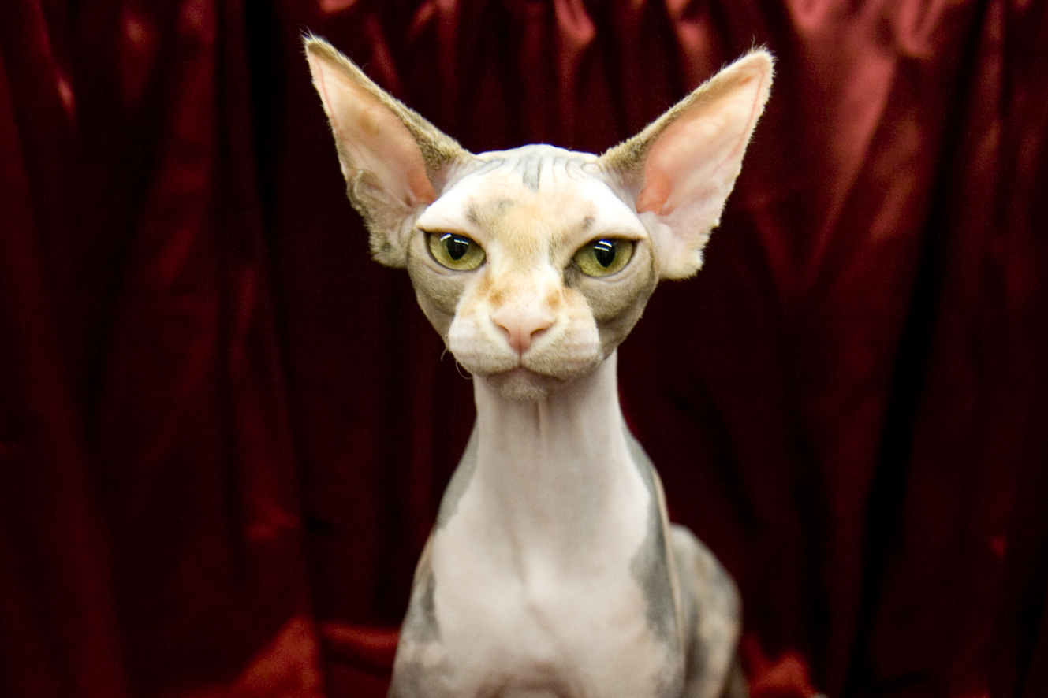
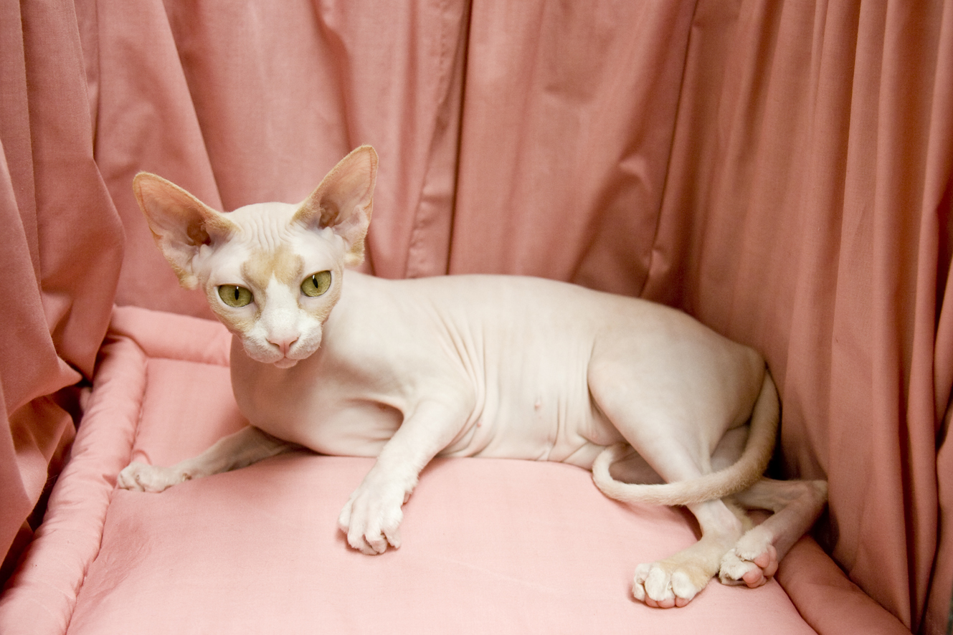
Manis Violet Storm
Filbitru Dusty Rose

In 1966 a domestic cat gave birth to a hairless kitten in Toronto, Canada. It was discovered to be a natural mutation and the Sphynx cat, as we know it today, came into existence. This cat and a few other naturally hairless cats have been found worldwide. These have magically been produced by Mother Nature and are the foundation for this unusual breed. Cat breeders in Europe and North America have bred the Sphynx to normal coated cats and then back to hairless for more than thirty years. The purpose of these selective breedings was to create a genetically sound cat with a large gene pool and hybrid vigor. This is a very robust breed with few health or genetic problems.
The Sphynx is not always totally hairless; there can be a fine down on the body, which makes the cat feel like a warm peach. Some light hair is often present on the nose, tail and toes. The texture of the Sphynx skin has been likened to suede, a hot water bottle, or a heated chamois. They can be registered in a wide variety of cat colors. The color is seen in the pigment of the skin and the few hairs that they do have. One of the questions most asked is "Don't they get cold?" Well, of course, if it is too cold for you it will be too cold for a hairless cat too. However, these cats are smart enough to find a warm human, dog or cat to curl up with or they will get under your bed covers.
This is a substantial cat, medium sized and strong, with adult males being larger than adult females. Sphynx have sturdy boning and good muscle development and should have a bit of a belly as if they just finished dinner. They have an open-eyed, intelligent face and a friendly expression. The Sphynx are extremely inquisitive and love to be the center of attention. They perform silly antics for your entertainment and are sometimes downright clumsy…on purpose it seems. They make great show cats because of this "look at me" attitude and they are easy for judges to handle. They prefer human attention but enjoy the company of dogs and other cats. They have an abundance of energy and mischief and are always with you, on you or showing off for you. "Love Mooch" is the perfect term for these amazing cats.
Because of the lack of hair that would normally absorb body oils, the Sphynx needs to be bathed periodically. Some people who suffer from cat allergies can tolerate living with Sphynx cats. However, depending on the type and severity of the individual's allergic reactions, there are still people who cannot live with this breed.
Sphynx lovers feel this is one of the most rare and unusual breeds in the cat fancy today…Sphynx are pure enchantment.

Manis Cattery 0746340078
Breeders of Quality Sphynx
Pictures are copyrighted by Manis Cattery. Notes are copyrighted to Dalpat. Not to be used without prior permission from both.

A CURIOUS CAT
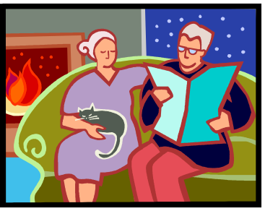

I am a cat lover, but I have the misfortune, like many, to be severely allergic to almost all of them. Within minutes of picking up or even patting a purebred Persian or just a simple fluffy moggy, my nose and eyes start to run and I begin sneezing uncontrollably. Because of this, I tend to take an antihistamine tablet before visiting anyone who owns a cat. But it isn’t practical to constantly take antihistamines. If people like me want to own a cat we need to look at some of the stranger breeds such as the virtually hairless Sphynx and the furrier Devon and Cornish Rexes.

I already own a Devon Rex named Suede, and her fur is very short and curly. For the most part she does not cause me any problems except for when she sheds her winter coat. Of course this always happens at the break of Spring when I’m already struggling with allergies from pollen.

Devons have an unusual appearance (visitors often ask me if Suede is ill or if I have shaved her), but I was still surprised when I met my first Sphynx. Dusty Rose is a cream and white adult Sphynx owned by breeders Sherin and Rod McGregor. They have five cats, and whilst talking to Sherin about Sphynxes I had a Devon Rex named Kit Kat sitting happily in my lap the whole time.

Dusty is a very friendly, active and remarkably curious cat that is happy to see visitors. There is some short fur on her nose, ears and tail, but the rest of her body is smooth and hairless like a human baby. Her skin feels very warm and soft and not greasy like I expected. Dusty loves to lick and groom the fingers of people patting her and she is very elegant and graceful as she bounds around the McGregors’ home. She is also best friends with Kit Kat and they spend a lot of time playing and sleeping together, and grooming each other.

Allergies to cats are caused by either a reaction to the cat’s shed fur, proteins in their dried saliva or accumulated dust and skin cells, known as dander. My own allergy is caused by fur so cats that shed heavily cause me much discomfort. If you are allergic to cat saliva or dander, sadly the Sphynx is not the answer for you. However their virtual lack of fur is a definite plus. “They don’t shed at all,” Sherin says. “We once had a visitor who actually gets catatonic from his allergy to cats. He held Dusty without any problems.”

The very hairlessness of the Sphynx means they require different care to other breeds. They are vulnerable to sunburn and the oil that all cats secrete from their skin cannot be absorbed by fur. Consequently a Sphynx should be bathed more often than an ordinary cat to remove any accumulation of oil. Sherin surprised me though in saying that she only bathes Dusty once every six weeks or so, considering that I thought it would be every week. They must be kept indoors to protect them from the elements and fights with other cats. Sphynx are quite susceptible to the cold and will snuggle up with other cats or under blankets. They also take well to wearing little coats and jumpers.

Sherin says that certain vaccines, like F3 and F4 can cause problems for Sphynxes and that prospective owners should do research beforehand. “With a Sphynx, their immunity is much lower,” she says. “So when you put a topical flea treatment on them it reacts straight away. It has been known to kill a Sphynx in a few hours.” She and Rod spent a year learning about Sphynxes before they felt ready to buy one. The source of this patience was their certainty that a Sphynx was the right cat for them.

Nevertheless a Sphynx isn’t as hard to look after as you might think according to Sherin. “It’s a misconception that they stink or that they’re very oily. You don’t need to bathe them every week,” she says. They are also more resistant to cold weather than it would seem. Sherin simply advises that temperatures that are cold for humans in light clothing would be similarly cold for a Sphynx.

However, you should be aware that Sherin and Rod are not your average cat owners. Along with Dusty Rose and four Devon Rexes, they also have a seven foot carpet python named Theo. Theo is kept safely behind glass and the cats are put away when they take him out for exercise. For their part, the cats are fascinated by the strange creature they share their home with. I held Theo and can honestly say that I am not allergic to snakes. I might have been ‘allergic’ to him biting me but thankfully Theo is very calm and gentle.

A typical Sphynx is hairless and has very large ears and eyes and various skin colours are possible as with any cat. Breed standards allow there to be fur on the extremities and a fine down on the rest of the body. Their bizarre appearance does not appeal to all. “A lot of people think you are doing the wrong thing by breeding them, because they’re bald,” Sherin says. “But this is the way they are. Their genes have naturally mutated to make them such a beautiful cat.”

Because they are rare and still quite new in Australia, Sphynxes are currently very expensive, costing anywhere in between $1500 and $2000 each. Marion Cooper, a Registrar with the Council of Federated Cat Clubs of Queensland Inc, says that the price of Sphynx kittens is unlikely to come down in the near future. “There are not many Sphynx cats in Queensland, half a dozen at the most. Breeders tend to sell them desexed,” Marion says. Consequently the supply of new kittens is very small.

Marion agrees that the strange appearance of the Sphynx may be off-putting to some people , but she doesn’t think this instinctive dislike is unique to the breed. “Some people like Siamese cats and others think they are horrible,” she points out. “People tend to either love cats or hate them in general, anyway.”

The Sphynx breed actually originates from a hairless kitten born in Toronto, Canada in 1966. The kitten’s hairlessness was due to a recessive gene mutation. For some time the breed was known as the Canadian Hairless . The name Sphynx is therefore a little misleading as the breed has no link to Egypt or the Great Sphinx of Gaza. ‘Sphynx’ became the more popular name because it owners felt it better describes a cat that has such a strange appearance, yet a regal and elegant nature.

To create a larger gene pool breeders selectively bred the Sphynxes with normal cats then back with hairless ones. The first breeding pair of Sphynxes was brought to Australia by Angela Irvine in 1995.

Sphynx cats have made some major appearances in popular media. In the Austin Powers films, the villain Dr Evil owns a Sphynx named Mr Bigglesworth. Another Sphynx appeared in an episode of the television sitcom Friends, this time named Mrs Whiskerson. When Ross saw Mrs Whiskerson he said memorably “why is it inside-out?” On Australian television, Sphynxes’ have been shown on ABC’s The Pet Show and Channel Ten’s The Panel.

There are other options than the Sphynx for cat lovers with allergies. Along with the Devon Rex, Marion suggests the Siberian Cat which is far less allergenic than other long-haired cats. Both of these breeds are much more common than the Sphynx, although perhaps it is this very rarity that gives that breed some of its attractiveness. There are several other cat breeds with very short hair, such as the Peterbald, Don Sphynx, Cornish Rex, and German Rex, with varying availabilities. The internet has a wealth of information on different cat breeds for those interested.

Sphynx cats do have their drawbacks. They need different care to normal cats; they are expensive and have a bizarre appearance. But in my eyes, they have one definite advantage over other cats. Whilst playing with Dusty Rose, I was not troubled by a single sniffle.

Written by Richard Munoz and used with his permission

