SCHEDULE A

Australian Cat Federation Inc.
39th National Championship Show
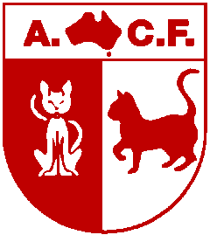
Proudly hosted by

Queensland Independent Cat Council (Inc)


June 12th, 2011
Join us in Brisbane

For a Cat Show with a truly International Flavour

with our Judges from South Africa, Austria, Japan, Canada, The United States, Argentina, New Zealand and Australia

Closing date for entries: 11th May 2011

Proundly Sponsored by

Show Venue
BALD HILLS STATE PRIMARY SCHOOL HALL
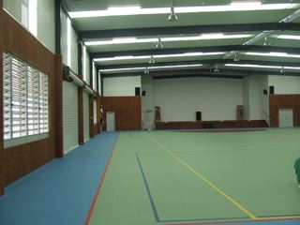 | While Bald Hills Primary School is one of Queensland oldest, first opened in 1866, the school hall is one of Brisbane’s newest.  Opened in January 2010, this newly constructed, large, hall is located only ten minutes from Virginia Palms International Hotel and less than 30 minutes from Brisbane Airport.
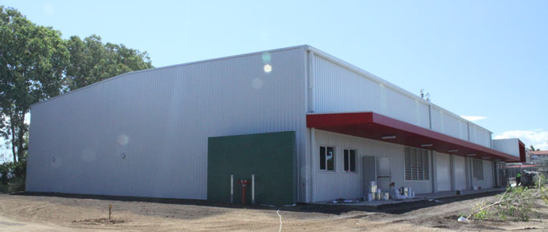

Strictly no food allowed in the hall, nor stiletto heals or black soled sports shoes as these damage the specially laid sports floor.

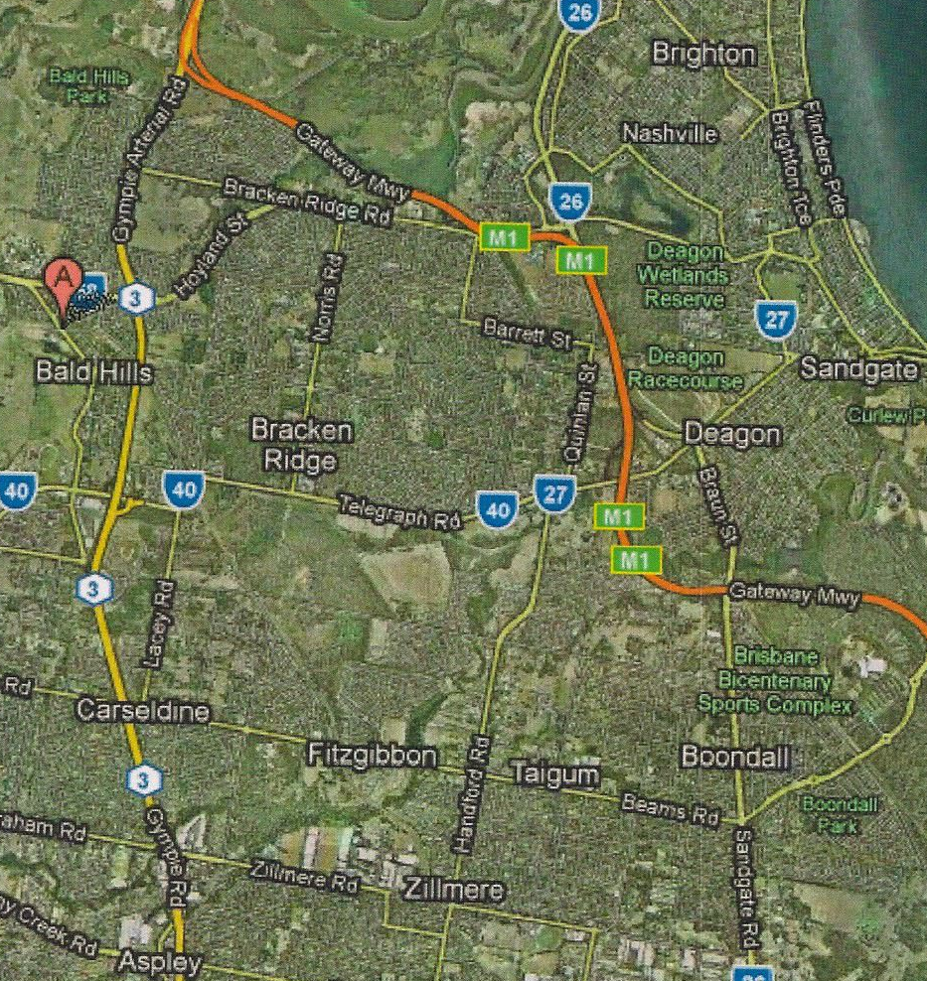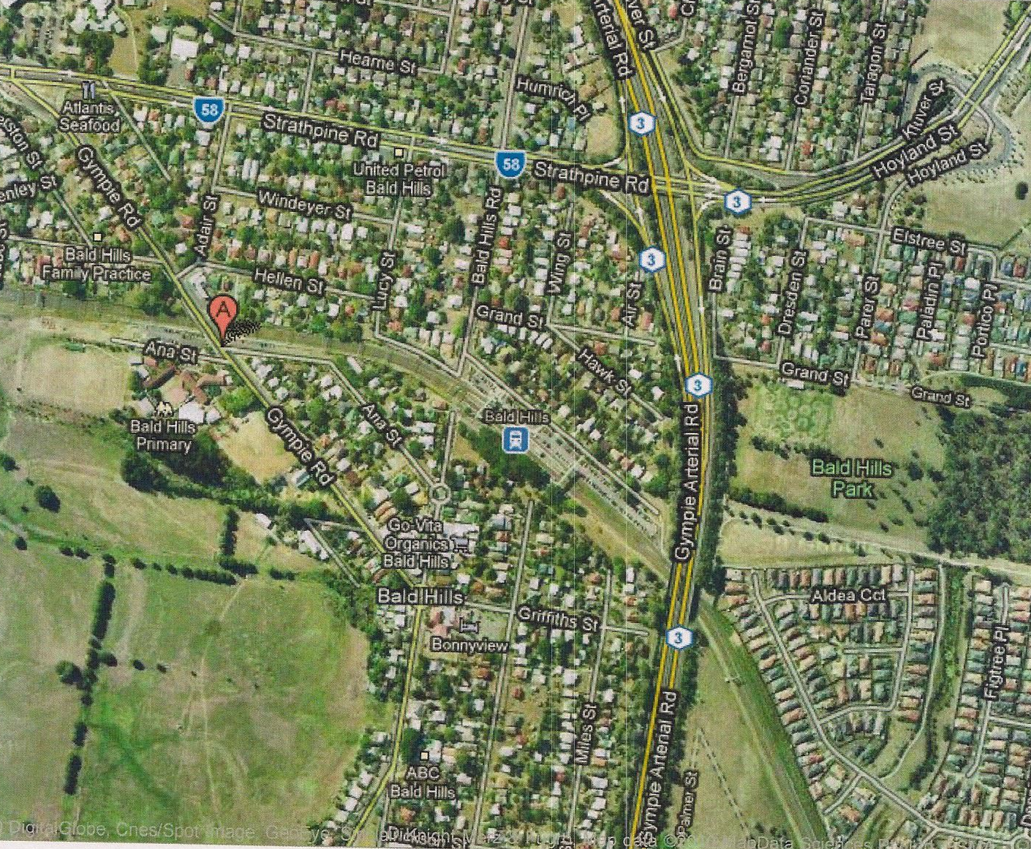

About the ACF

The Australian Cat Federation Inc, formed in 1972, is an Australia wide, recommendatory body with affiliates in all States and Territories. The ACF has endeavoured over the years to bring uniformity to the cat fancy in various key areas which have an effect on cat breeding and cat showing.

Show Style

The 2011 ACF National Show will be run as an Australian Open Championship style show. Judging will be bay style and follow the Australian Cat Federation Inc. Rules and Regulations.

Show Day Timetable

Random In Cage Vetting from 7:30am
8.30 - Judging commences
9.00 – 3.30 - Show open to public
3:30 – Main Judging finishes
4:00pm – Judging of Supreme and Presentations

7.30pm – Show Dinner

Awards
There will be Top Ten placings in each of the four rings for Best Kitten, Cat and Desexed in Groups 1, 2 and 3 and Top Ten placings in each of the four rings for Group 4.

Best of Breed Awards will be awarded in each ring for Kitten, Cat and Desexed. These Awards will be in the form of quality Rozettes and Product from our Major Sponsors. The Major Awards to be won are Best All Breed Kitten, Cat and Desexed in each Ring. From these the Overall Supreme Exhibit will be Judged.

Supreme Companion will be judged from the Best Group 4 exhibit from each Ring.

Ring 1 – Awards include Quality Rozettes, Ozpet Litter

Ring 2 – Awards include Quality Rozettes, Australian Animal Nutrition Premium Food & Supplement Products

Ring 3 – Awards include Quality Rozettes, Australian Animal Nutrition Premium Food & Supplement Products

Ring 4 – Awards include Quality Rozettes

All Rings – Best of Breed Awards include Rozettes

Best All Breed Kitten, Cat & Alter in each Ring – Quality Rozettes, 5kg Australian Animal Nutrition Premium Food, PP20 pet transport cage,

SUPREME COMPANION OF SHOW – Awards include Quality Rozette, 5kg Australian Animal Nutrition Premium Food and Supplement Products, PP20 pet transport cage,

SUPREME PEDIGREE EXHIBIT OF SHOW – Awards include Quality Rozette, 5kg Australian Animal Nutrition Premium Food and Supplement Products, PP20 pet transport cage.

OUR SPONSORS
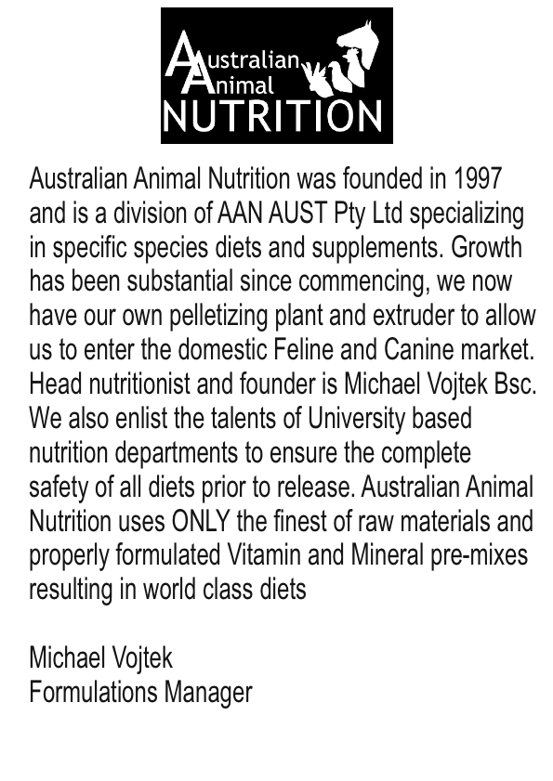

Makers of
Australian Animal Nutrition was founded in 1997 and is a division of AAN AUST Pty Ltd specializing in specific species diets and supplements. Growth has been substantial since commencing, we now have our own pelletizing plant and extruder to allow to enter the domestic Feline and Canine market. Head nutritionist and founder is Michael Vojtek, Bsc. We also enlist the talents of University based nutrition departments to ensure the complete safety of all diets prior to release.

Australian Animal Nutrition uses ONLY the finest of raw materials and properly formulated Vitamin and Mineral pre-mixes resulting in world class diets.

Michael Vojtek
Formulations Manager

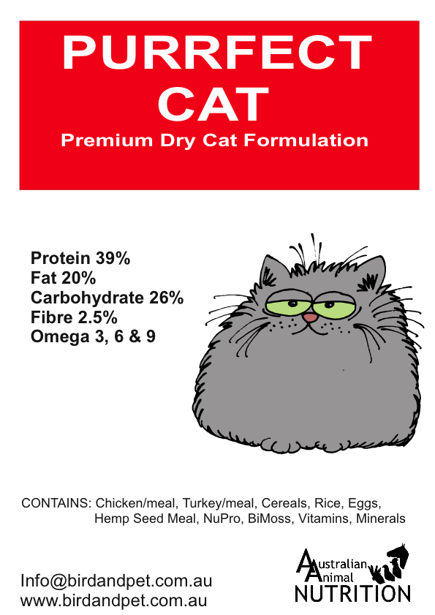

OUR SPONSORS
Oz-Pet Animal Litter wood pellets are the ulitimate environmentally friendly product.  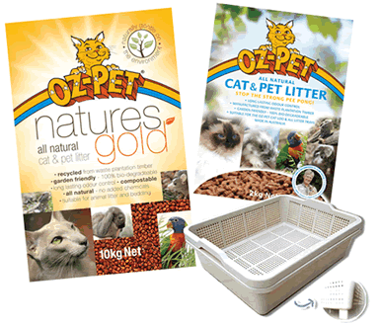  - Eco friendly litter manufactured from waste plantation sawdust.  - Recycles waste wood that would otherwise be dumped.  - Contains no additives.  - Can be composted or used as mulch.  - 100% organic |   For sponsorship enquiries  please contact  Jeanette Rossiter  National Sales & Marketing Manager  jeanette@oz-pet.net.au

Now available in a variety of convenient sizes
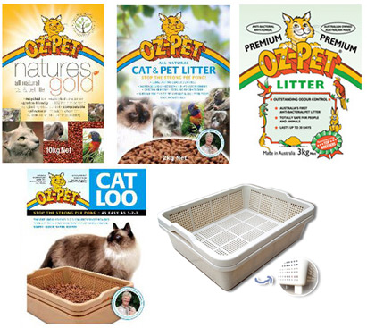

Our Judges

GROUP | RING  ONE | RING  TWO | RING THREE | RING  FOUR
1 KITTENS | Yukiko Hayata  CFA Japan | Bernadette Roberts  ACF | Don Finger  ACFA - USA | Lynel Du Toit  SACC  South Africa
1 CATS | Yukiko Hayata  CFA Japan | Carlos Lopez  TICA Argentina | Heather Brown  ACF | Lynel Du Toit  SACC  South Africa
1 DESEXED | Yukiko Hayata  CFA Japan | Bernadette Roberts  ACF | Don Finger  ACFA - USA | Lynel Du Toit  SACC  South Africa
2 KITTENS | Danny Cook  ACF | Aline Noel  TICA Canada | Heather Brown  ACF | Carlos Lopez  TICA Argentina
2 CATS | Yukiko Hayata  CFA Japan | Ian Honour | Heather Brown  ACF | Carlos Lopez  TICA Argentina
2 DESEXED | Yukiko Hayata  CFA Japan | Ian Honour | Monika Dany  TICA Austria | Barbara La Rocca  ACF
3 KITTENS | Dorothy Dever  ACF | Aline Noel  TICA Canada | Monika Dany  TICA Austria | Barbara La Rocca  ACF
3 CATS | Danny Cook  ACF | Gary Brown  ACF | Monika Dany  TICA Austria | Carlos Lopez  TICA
3 DESEXED | Danny Cook  ACF | Aline Noel  TICA Canada | Don Finger  ACFA - USA | Carlos Lopez
4 COMPANIONS | Debbie Bright  QICC | Lynel Du Toit  SACC  South Africa | Don Finger  ACFA - USA | Monika Dany  TICA Austria
All Breed Kitten  Cat  Desexed | Yukiko Hayata  CFA Japan | Aline Noel  TICA Canada | Don Finger  ACFA - USA | Monika Dany  TICA Austria
OVERALL SUPREME OF SHOW
Will be judged by Judith Lewis (ACF) from the nominated All Breed Kitten, Cat and Desexed from each Ring
Overall Supreme Companion will be judged from the Best Companion in Show from each ring.

ABOUT OUR JUDGES
 | Yukiko Hayato  CFA ALLBREED APPROVED --- Born 1950 in Tokyo Married, Animalitarian (I love cats, dogs and horses) Horsewoman (I used to own Hayata Farm in Hokkaido, bred Thoroughbreds-Japanese Triple Crown winner etc, many Classic winners). Became a CFA Judge in 1983. Cattery Name......She-Shah. Breeding Persian, Siamese, Himalayan, Abyssinian. Member-Mt. Fuji Hokkaido CC, Mt. Fuji Northern CC. Mt. Fuji Tokyo CC Director of Elms Pet Clinic (Veterinarian), Lecturer in Feline & Equine Medicine. My mother, Tokuko (Suzie)Yamazaki was CFA Judge also and retired a few years ago.
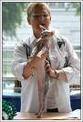 | Aline Noel Garel  ALINE NOEL-GAREL  --ALLBREED APPROVED—  TICA & LOOF  Canada  Sphynx  Amenophis Prefix
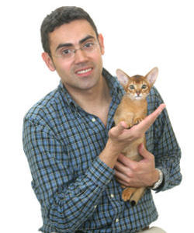 | Carlos Lopez  I'm an international all breed TICA judge. I live in Buenos Aires, Argentina. I'm a high school Maths teacher and I teach Statistics at the Economic College, University of Buenos Aires.  I have been involved in the Cat Fancy for 17 years. The first pedigree cat I owned and showed was a black persian male, that was in 1993. In 1996 I began breeding British Shorthair cats under the prefix of "Pampa". I've been breeding Abyssinians since 2003 and Bengals since 2008 with equal success winning many TICA regional awards. At the 2008-2009 TICA show season the best International Abyssinian Cat / 13th Best International Cat / Best Allbreed Cat in Southern Europe was from my cattery, LA IW SGC Pampa Mojito Night Fever.  I've been envolved with many TICA clubs in my region serving on various committees. I was a founder member of Tango Cat Lovers Club in 1998 and TICAdelPLATA Club in 2008. Currently, I'm the counselor for this club. I entered into the TICA Judging Program in 1997. I qualified as a International Provisional All-Breeds judge in 2005 and have judged extensively nationally and internationally in Argentina, Brazil, Chile, Colombia, USA, France, Switzerland, Germany, Austria and United Kingdom including the first TICA show in Scotland. In 2010, I will have the honour to judge the TICA Annual show in Santa Clara, California. 2011 ACF National Cat Show will be my first time in Australia, a country I have always dreamt to visit.

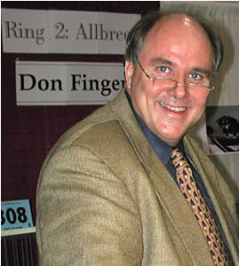 | Don Finger  My wife, Judy, got our first purebred cat, a Chin. Silver Persian, for Christmas in 1974. We entered her in our first cat show in 1975 and saw  our first Himalayan, and we were hooked. However, it was not until 1982 that we were able to buy our first Himalayan, but then our breeding program started. We wanted to produce Chocolate and Lilac Lynx Point Himalayans. Well, anyone who works with these will tell you it is like taking one step forward with the Lynx Points, and two or three steps back with the Chocolate and Lilacs. Needless to say, we did not get far.  We granded our first CPC Himalayan in 1990, and this male clicked with the rest of our Himalayans, with many Grands to follow. We started into Exotics in 1990, followed by Havana Browns in 1991, but only until 1994. We then were given our first Selkirk Rex in 1994 and asked to develop the color pointed program for the Selkirks. I was the person who presented the Selkirks' for Championship statues in ACFA in 1997. Because of the Selkirks, I have had the occasional Brit in my breeding program, and in 2003, got my first Turkish Van.  Due to my "string" of Grands starting in 1990, I was approached in 1992 to enter the Judging Training Program, becoming a SP judge in 1994. After over 40 SP judging assignments, I became an AB judge in 1998, and a Training Judge in 2003 and with well over 100 AB judging assignment, I became a Teaching Judge in 2008. I have assisted in teaching several judges schools in the past few years, but will be teaching my first solo judges school in June of this year.  Over they years, I have served on the Himalayan Breed Committee, being it's chair for more years than I wish to count. I have also served on the Selkirk Breed Committee, and now am the Turkish Van Breed Chair.  I have also served on many committees for ACFA, and am currently in my second term as ACFA's 2nd Vice President.
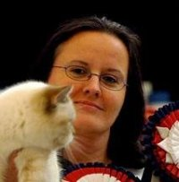 | Monika Dany  1990 – First Pedigree cat, Bobbycat’s Adagio, Blue British Shorthair neuter,  1991 - Adagio shown all over Europe at Fife shows to European Premier. In same year acquired Nemorino von Wildegg, seal point Birman, neuter, show to Premier, initial contact with pointed cats and their unique personaility.  1993 – Bred first liter of CPC including Modany’s Apocalypse Angel, tortoiseshell British Shorthair, who is still alive.  1994-1996 Steward at Fife shows.  1996 – First contact with TICA, clerked (after having a clerking school the night before the show) at the first TICA Show in Austria.  1997 – Became member of TICA and breed section BS.  2000 – Became member of the BS/BL breed committee  2001 – Accepted into the TICA judging programme  2002 – First judges license as a TICA Probationary Speciality Judge.  2006 – Advanced to Provisional Allbreed Judge  2007 – Co-founder of British Breed Club, a club to promote the British Breed Group in TICA  2008 – Founded my own TICA Club – All About Cats  2008/2009 – Showing Modany Easy Rider, blue tabby point British Shorthair to 10th Best Cat International in TICA, took no judging assignments during that time.  2010 – Applying for Approved Allbreed Judge (that means a minimum of 110 shows judged – all over Europe, USA and Japan)

 | Lynel Du Toit  For as long as I can remember, I have loved all animals, and grew up surrounded by them [and still am!]. So it was a natural progression that for almost all my working life I have worked for veterinary surgeons.  I started exhibiting Siamese in 1978, and soon thereafter began stewarding at shows. I bred my first litter in 1979. I was invited to train as a judge in 1982 and qualified as a SACC all breeds judge in 1987. In 1988 I co-founded the Siamese Breeders' Group of SA, and am currently their breed council delegate.  I have visited and stewarded at shows in England, and maintain regular contact with friends in the cat fancy there. The first of my judging visits to Australia was in 2002, and in 2006 I judged at the NZ Nationals in addition to 4 shows in Australia. In 2009 I judged at 3 shows in Australia.  I have bred many award-winning Siamese over the years, and still breed Siamese today. My other love is dogs, and used to breed and field-trial Labradors. More recently I breed, show and train German Shepherd Dogs. My great interest is keeping abreast of trends in registered cats and my great joy and privilege is that I get to handle and judge superb cats at shows.
 | Barbara La Rocca  I was introduced to Burmese in 1984 and instantly fell in love with the breed. I have held various positions in the Gold Coast Cat Club, Burmese Cat Society and Club 23 (Abyssinian club) became a Delegate to QFA council meetings and was Vice President of QFA for some years. I started training (in 1988) as a Shorthair judge and during that time decided to breed Abyssinians as well. I have also imported Somalis and bred Burmillas, Tonkinese and Maine Coons. After a couple of years of judging Shorthair cats I started my training in Longhairs and in 1998 became an All Breeds Judge. I have judged and continue to judge throughout Australia and New Zealand and have judge In Kuala Lumpur. I am currently President of QFA a position I have held since 2001.
 | Bernadette Roberts  Bernadette purchased her first Tonkinese in 1979 and, later that year, adopted her first Oriental as he was in need of a loving home. She is married to Ian Honour and, from 1990, they commenced breeding Orientals (mostly silver) under the “Byanda” prefix. She has bred and owned many Oriental Cats of the Year, including the well-known and much-loved Byanda Tail of the Century.  In 1990, she was introduced to the unique characteristics and playfulness of Turkish Vans when she took home Vanstar Willow Wisp of Vanwillow, who became the foundation queen of a multi–award–winning Turkish Van line. Vanwillow Wonder Woman won the first ACF AoE on the mainland and was the first CCCA Champion Turkish Van. Vanwillow Cats of the Year have included Whispering Jacq and Warrigal Wonder.  Bernadette is a groups one, two and four judge has been a member of many cat–related committees since 1990. She is currently Hon. Secretary of FCCQ Inc., President of the Siamese and Shorthair Cat Club of Queensland, and Hon. Secretary–Treasurer of the Classy Cats Cat Club of Queensland. She is an experienced show manager and has developed and run ring clerk and steward training programs. Bernadette also has a great interest in ongoing information and education programs for judges, breeders, and exhibitors. She is committed to cat welfare and the breeding of quality, happy, pet cats and always enjoys judging Group 4 exhibits because of the great diversity of colours and personalities seen.

 | Ian Honour  Ian’s love of cats began in his childhood with the raising of a stray cat’s litter.  Ian was introduced to the Siamese–Oriental type when he commenced dating Bernadette Roberts and was fascinated with her Foreign White “CP”. CP (short for “Cuddle Puss” was a special character who could detect when you felt off colour and be waiting on the bed to provide cuddles for you when you rested. The other special feline in the house was Joel, a blue mink Tonkinese. Joel was eight kilograms of rippling muscle. He was a true domestic panther.  Since marrying Bernadette Roberts in January 1985, they have bred Orientals together under the ’Byanda’ prefix from 1990. Ian and Bernadette have also been enchanted by, and bred, Turkish Vans since 1990, when GDGC Vanstar Willow Wisp of Vanwillow entered their lives and introduced them to the unique characteristics and playfulness of this breed. Byanda Tail of the Century (Olivia) was the first cat to receive an ACF Award of Excellence on mainland Australia. Ian is an experienced Group Two Judge and, since 2008; also a Group One Judge. He has been a member of numerous cat–related committees and the co-breeder and co-owner of many Cats of the Year, in both the Oriental and Turkish Van breeds.  Ian has over 25 years experience as a CPA accountant and has worked internationally on AusAID projects. He is currently Treasurer of the Siamese and Shorthair Cat Club of Queensland Inc.  Ian is committed to cat welfare and care of all pets, especially companion cats. He was adopted by a cream and white mackerel tabby “gentleman” who arrived at “Byanda–Vanwillow” over eight years ago and decided to take up residence. He thoroughly enjoys judging Group 4 exhibits whenever he has the opportunity as these exhibits provide a unique challenge with their wide and varied heritage.
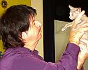 | Gary Brown  Gary entered the cat fancy in 1978 and together with his wife Heather, over the past 30 years, has bred top quality Siamese and Orientals and established the Bombay breed in Australia. Their first prefix was granted in 1979. Cat of Year awards were achieved in eight consecutive years with the Silverize prefix.  Gary gained his All Shorthair (Groups 2 and 3) licence with QFA Inc in 1995 and continued his training with FCCQ gaining his All Breeds licence in 2000. Gary has judged in all States of Australia and in NZ and enjoys judging every breed of cat.  Gary was a founder and President of the Siamese and Oriental Cat Club of Qld and has previously held many positions in the cat fancy including Executive Member and All Breeds Tutor Judge of QICC, President of QICC Judges Assoc, Delegate to QFA Council, Delegate to FCCQ Council and Delegate to ACF Judges Guild.

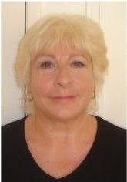 | Heather Brown  Heather entered the cat fancy in 1978 and together with her husband Gary, over the past 30 years, has bred top quality Siamese and Orientals and established the Bombay breed in Australia. Their first prefix was granted in 1979. Cat of Year awards were achieved in eight consecutive years with the Silverize prefix.  Heather gained her All Shorthair (Groups 2 and 3) licence with QFA Inc in 1995 and continued her training with FCCQ gaining her All Breeds licence in 2000. Heather has judged in all States of Australia and in NZ and enjoys judging every breed of cat.  Heather was a founder and President of the Siamese and Oriental Cat Club of Qld of which she has also been Secretary and has previously held many positions in the cat fancy including President and All Breeds Tutor Judge of QICC, Delegate to QFA Council, Delegate to FCCQ Council and Delegate to ACF Judges Guild.
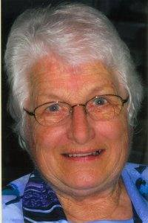 | Dorothy Dever  Dorothy entered the cat fancy in 1957 as an exhibitor. She began breeding Burmese under her Kachin prefix which was granted in 1974. Dorothy’s special breed interests are the Burmese and the Siamese and she showed the first Blue Tortie Burmese in Queensland to gain Champion status.  Dorothy gained her All Shorthair licence in 1975 with the then Feline Council of Queensland and then moved to QFA Inc when it was formed. Dorothy has judged throughout Australia and in NZ.  Dorothy is currently the Registrar for QFA Inc and is a Life Member of QFA Inc and also the Burmese Cat Society of Qld. Dorothypreviously served as the inaugural Secretary for QFA Inc in 1975. She was also the inaugural Secretary for the Burmese Cat Society of Queensland in 1975 and again served as Secretary and Treasurer for the Club during the 1990’s.
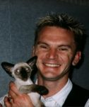 | Danny Cook  I first purchased a blue point Siamese kitten out of a litter of seal points,she was the only blue and with out knowing by purchasing her my whole life was going to change. In 1985, I think it was, I wanted to learn more about this beautiful breed of cat which I had obtained and I started searching for all the information that I could find .  I was told that there was a cat show and I was invited to attend. This led to me purchasing a seal point breeding girl who was named Woodene Seal Princess, who was later spayed as she was not a breeding girl but did very well as a show spey. I have bred Siamese , Orientals, Burmese and Exotic Shorthairs and I must admit that I have had show winners in all the groups. I had two separate breeding prefixes Siamdebonn for all of my Siamese and Orientals and Hoodat for my Burmese and Exotic Short hairs.  I began my group 2 judges course and became a qualified group 2 judge in 1994 and when of course the group3 judges course was available I certainly applied and became in 2000 a qualified group 3 judge.  I like the judging part, of course, but I like talking to the breeders as I find as judges we learn more from the breeders and all judges are always learning and should be open to new ideas and no two judges think the same way or usually place the same cat, we all think differently.

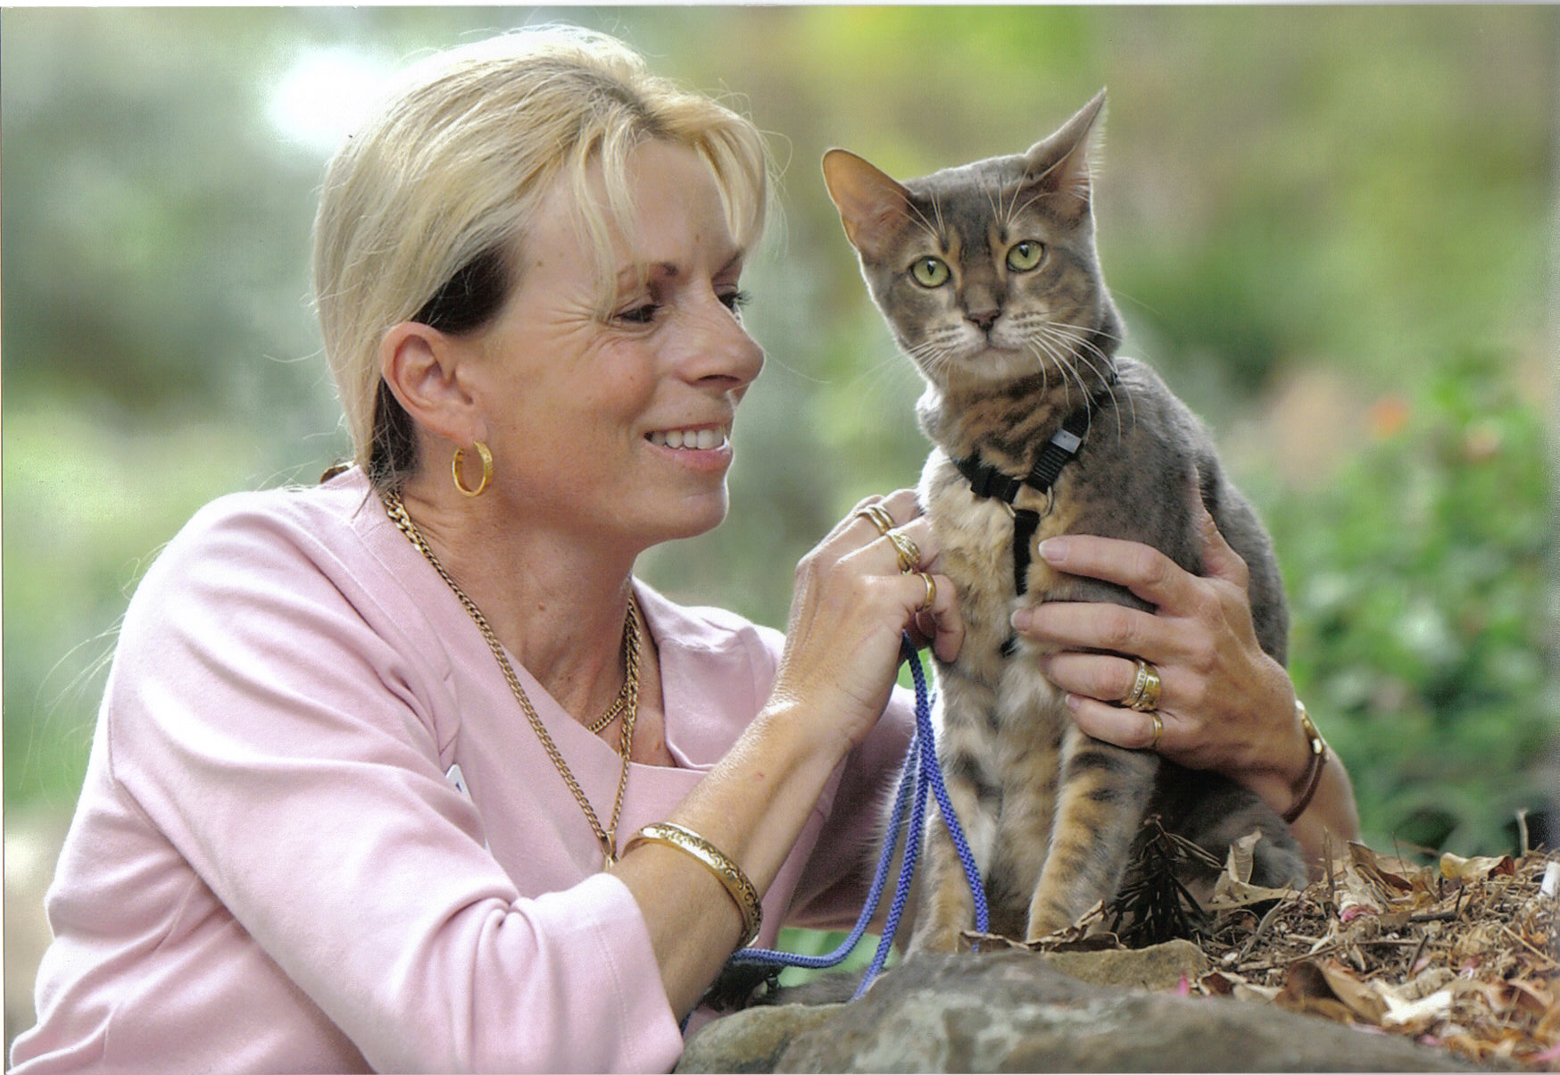 | Debbie Bright  Debbie is a fully qualified QICC (Inc) Companion Judge, has run many shows for QICCC and Little Paws Kitten Rescue Association which she is President. Little Paws Kitten Rescue Association (affiliated with QICC) is a made up of a caring team of people throughout Brisbane, the Gold and Sunshine Coasts, Ipswich and the Downs areas that help little orphaned, older kittens and mamma cats that need TLC. Through her dedication with animal welfare, especially at their most vulnerable, many severely abused cats and kittens have been cared for and found new homes. Debbie also shows her beloved companion cats, including “Sookie” rescued from certain death at the gates of the RSPCA when 10 years old, as well as desexed Maine Coons, Bengals and Selkirk Rex. Although only on a small scale Debbie has also bred Siamese and Selkirk Rex under the Petitpaws prefix.  Debbie has served as QICC Vice President and is currently on the Management Committee and Executive of QICC (Inc).
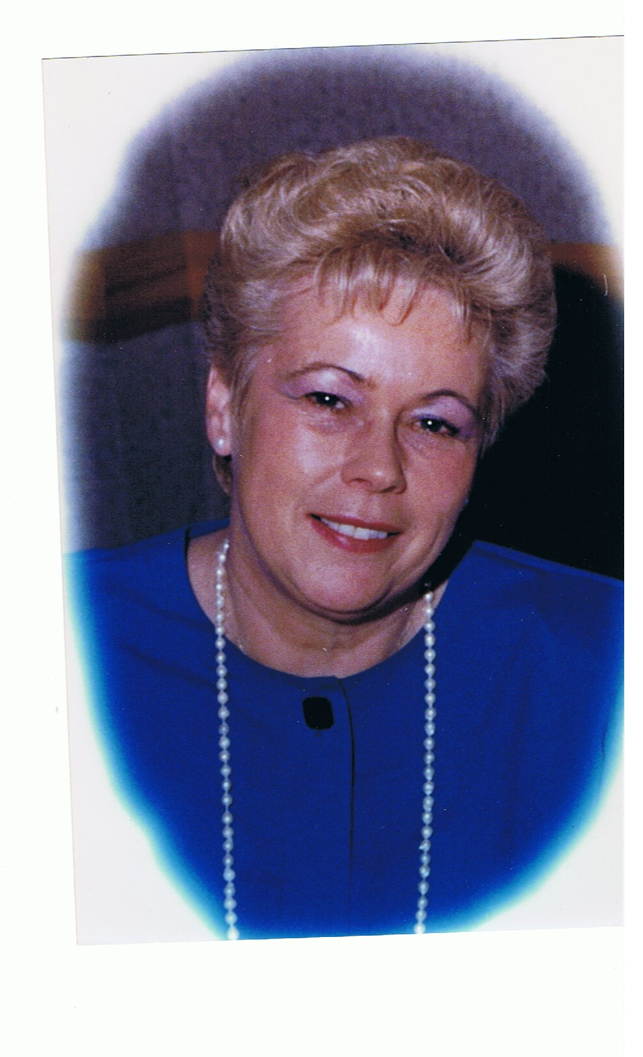 | Judith Lewis  ALL BREEDS INTERNATIONAL JUDGE, QUEENSLAND FELINE ASSOCIATION, ACF NATIONAL COUNCIL AUSTRALIA.  I have been a member of the Cat Fancy for 37 years gaining my All Breed Judges licence of many years with New South Wales CFA Inc. formally RAS Cat Control. During this period I have been involved in all executive positions within Club management, Tutor Judge and Co-Ordinator of Judging and Stewarding courses, along with the pleasure of holding Life Memberships and Patron to a number of clubs. I decided to move from N.S.W. to the Gold Coast, Queensland in 2001 to retire, relax and enjoy myself in this beautiful tropical, coastal part of the world.  At present I am Secretary to Queensland Feline Association Inc. in Queensland, which is the largest Pedigree registering body in this State, QFA inc. council is under the umbrella of the National body of the Australian Cat Federation plus I am delegate to Council for the Cairns Cat Club. My first cats were Siamese and Persian and then with a friend in 1967 imported the first Birmans into Australia where we developed and promoted the popularity they enjoy today. Recently I have taken on the challenge of owning, breeding and showing the Gentle Giant ….Maine Coons.  During my Judge’s training I have owned and bred some delightful breeds of cats, and it is my greatest pleasure to be invited around Australia and overseas to handle exhibitor’s precious felines in the Judging ring, along with the treasured friendships that have been made. The world is becoming a smaller place and Cat Fancies all over the world are working towards better management with cats, along with great strides in the health matters of many breeds. I am happy to be part of this future.

Show Rules

Please read the ACF show rules below carefully. Where no ACF show rule applies then the rules and regulations of QICC (Inc) will be adhered to. Please contact the QICC (Inc) Secretary should you require a copy of the QICC (Inc) show rules.

The Australian Cat Federation (Inc) Show Rules
1. All exhibits, local and Interstate, excepting unpedigreed must be registered with and issued with an approved registration number by a recognised controlling body or be eligible under By-Laws 1.3
2. All litters must be recorded with the recognised controlling body and must be a minimum of 12 weeks of age on the day of the show.
3. Kittens will not be eligible for individual kitten classes below the age of 12 weeks on the day of the show.
4. The number of kittens in each litter must be stated on the entry form. The Show Secretary must be notified prior to the show date if any kitten(s) included in the litter have died since the entry.
5. All cats and kittens must be immunised against F.I.E. with the exception of young kittens which may be given a temporary or partial vaccination at the discretion of the veterinarian.
6. All adult cats entered for competition, including titled cats, must compete in their appropriate Open class (whether entire or desexed). Kittens must be entered in their individual age classes (under 5, 7 and 9 months) unless entered as litter only (under 4 months). Pairs, braces and teams must be owned by the one exhibitor.
7. No cats obviously pregnant may be exhibited. No cats obviously nursing a litter may be exhibited without her litter. No vasectomised cat may be exhibited. No female cat desexed by tubal ligation may be exhibited.
8. Entries must be made on the appropriate entry form and must be in the hands of the Show Committee by the stated closing time. All entry fees must accompany the entry form. Entry fees will not be refunded under any circumstances.
9. The Show Committee reserves the right to refuse or return any entry or entries. Exhibitors whose entries are refused, to be notified in writing by registered mail within seven (7) days of close of entries. Copy of such letter to be forwarded at the same time to the Secretary of the ACF Inc.
10 The age of all exhibits shall be computed from the day of their birth to the day of the show,
(a) Kittens: exhibits under nine (9) months of age, and (b) Cats: exhibits nine (9) months of age and over on the day of the show.
11. An exhibit must be the bona fide registered property of the owner or lessee in whose name it is entered. If owned by more than one person, the names of all part owners must be shown on the entry form.
12. One free pass will be issued to the exhibitor. These passes are not transferable. Where the exhibitor is a partnership, whether owner or lessee; additional free passes may be issued, equivalent to the number of exhibits entered or members of the partnership whichever is the lesser.
13. The ACF Inc. will be most anxious for the care and safety of the cats and kittens brought or sent for exhibition or any other property entrusted to it, but it must be strictly understood by all exhibitors, and all other persons, that this body will not accept responsibility for the loss, damage or detention of any exhibit or any property, whether arising from accident or other cause by its officers, agents or any other person. ALL PERSONAL PROPERTY LEFT IN THE HALL IS THE OWNER'S RESPONSIBILITY.
14. No cat or other animal, other than exhibits, shall be allowed within the precincts of the exhibition for the duration of the show.
15. All exhibits must be brought to the hall in suitable baskets or containers. No exhibit will be accepted if on leads, wrapped in towels, etc.
16. No exhibit shall enter the hall if it has at any time during the period of thirty (30) days immediately preceding the day of the show been in a cattery affected with Feline Enteritis or infectious disease. If a cat is under treatment for any complaint, it should have a certificate from the attending veterinarian as to contagious possibilities or otherwise. The certificate must be handed to the Show Veterinarian before the examination, or where 17 (b) applies, to the Show Manager who will arrange vetting of the exhibit. The final decision will rest with the Show Veterinarian. People from an infected cattery should not be permitted to officiate at cat shows.
17 All exhibits must pass the Veterinary Inspection.
(a) A duly qualified Veterinary Surgeon shall examine each cat, whether entered for competition or exhibition only, or
(b) A Veterinary Surgeon shall be present at the show from 7:30 am until midday, inspecting animals of his selection during that period. Entry to bays during judging not permitted except at show manager's request.
The Veterinary Surgeon shall order any cat to be removed from the show if, in his/her opinion, it is suffering from any infectious or contagious disease or has external parasites. Their decision in this regard shall be final. Should the Veterinarian reject one of an exhibitor’s cats or kittens all the exhibitor’s entries may be rejected.
18. A Veterinarian shall examine all adult entire male cats for entirety. If found to be monorchid or cryptorchid the Veterinarian will disqualify.
19. If during the course of the show, an exhibit should be found to be ailing, or distressed through any cause, the Show Manager may at his/her discretion request the exhibit be removed from the hall.
20. While ACF Inc. take every care of animals entered in a show, all entries are accepted at the owners/lessees risk.
21 Plain white or coloured curtains (if used) and towel or blanket must be in cages prior to the commencement of judging. No other distinguishing objects are allowed until judging is completed but hot water bags, covered with plain material only, will be permitted in winter. Non distinguishing litter trays may be in the cage during judging.
22. No foodstuffs are allowed in cages prior to judging but drinking water may be provided.
23. Litter trays must be provided by exhibitors.
24. Grooming of exhibits benched may be continued until exhibitors are requested to leave the judging area prior to judging. Aerosol sprays, methylated spirits and powdering are prohibited in the Show Hall. Transgression will result in the disqualification of the exhibit.
25. Boxes, baskets etc. must be placed out of sight after the exhibit is benched.
26. Late arrivals will only be accepted at the discretion of the Show Manager but exhibits not in their cages when the judges are called to the floor will automatically be disqualified.
27. No cat or kitten may be removed from the vicinity of its cage without special permission from the Show Manager.
28. No exhibit may be removed from the hall before completion of prize-giving without the permission of the Show Manager.
29. The Show Committee reserves the right to amend Prize Lists.
30. All exhibits at ACF Inc. shows are judged according to the Standards of the ACF Inc. No breed numbers will be used. All breeds and colours and patterns will be fully written.
31. The ACF Inc. show will contain the following sections for competition:-
GROUP 1 Persian, Exotic, Birman, Turkish, Ragdoll, Maine Coon, Norwegian Forest Cat, Siberian
GROUP 2 Siamese, Foreign White, Oriental Shorthair, Balinese, Foreign White Longhair, Oriental Longhair.
GROUP 3 Other Shorthairs and Somali, Scottish Fold Longhair, Scottish Longhair, Cymric, Selkirk Rex Longhair,
LaPerm Longhair.
GROUP 4 Companion Exhibits.
EXPERIMENTAL/ASSESSMENT All new and developing breeds/varieties.
32. Desexed exhibits shall not compete against entire exhibits except where special regulations apply as in side classes such as eye colour etc. or for Supreme Exhibit. For Top 5/10 Kittens, desexed and entire kittens will compete together.
33. Challenge and Award of Merit certificates will be awarded for Best Male, Best Female, Best Neuter and Best Spey in each colour (A.O.C. and unpedigreed excepted or where special regulations apply) irrespective of the number of entries, provided the exhibits reach the standard required by the judge. Challenge and Award of Merit certificates awarded to Supplementary Register exhibits must be marked with the letters “S.R.”. However, Sub-Register status will not be indicated on the Judges’ slips. Companion Merit Award will be allowed for Best Neuter and Best Spey for the Part Pedigree and Domestic Sections respectively.
34. A Judge’s decision on the merit of an exhibit shall be final unless such decision is contrary to the rules under which the show is conducted. Judges shall be empowered and instructed not to award any prize, Challenge or Award of Merit Certificate or Companion Merit Award to any exhibit which they consider is not of sufficient merit. The judge may award a second place and may withhold a prize altogether where the exhibits are not, in his opinion, of sufficient merit.
35. Any exhibit which is unable to be handled by the judge will not be judged. Any exhibit found to be under sedation will be disqualified.
36. Officiating judges may enter exhibits in competition providing they are only entered in sections in which they are NOT officiating. Such judges are categorically excluded from conferring with judges of cats in sections in which they are exhibiting and from sitting on any panel including for Supreme Exhibit in the event that any exhibit owned by such judges should be presented to such panels. Such judges/exhibitors cannot present exhibits for vetting, nor bench any exhibit. Officiating Judges may put cats on exhibition.
37. Where possible stewards will not assist judges in classes in which they have entered exhibits.
38. Each judge will submit his Best and Reserve Special Awards to the Show Management for submission to the Panel judging Supreme and Reserve Supreme Exhibits. Panel judging may be used at the discretion of the Show Committee for any category, but all decisions of the individual members of the panel must be by ballot.
39. In the event of a split decision during panel judging, the panel will be instructed to determine between two of the exhibits, and then between the winner and a third exhibit and so on until an overall winner is established.
40. Any complaint regarding the management of the show must be made in writing to the ACF Inc. secretary together with $20.00 fee, within two (2) days of the show. The fee will be refunded if the protest is upheld.
41. No cards or ribbons, other than those won at the show, may be displayed.
42. Supplementary register exhibits shall compete against full register exhibits in their appropriate classes if they are, or have been, part of an approved program aimed at producing cats of an established breed/variety and standard in the Open Classes where Challenges and Award of Merit certificates are awarded. Such cats are eligible for these awards but the certificate shall bear the letters “SR” before the name of the cat. Exhibits of a new variety (colour, marking, coat quality) of an established breed shall compete in Open Classes for AOC/AOV exhibits. The proposed standard of points must be forwarded with the entry. Supplementary Register exhibits are eligible for Best of Breed/Variety and Best in Show Awards.
43. All cats entered for competition shall have all claws clipped.
44. Judges are instructed to ignore tattoo marks and other similar forms of identification (e.g. reaction to microchip insert) in show cats.
Signs of a cat having been shaved for Autosomal Polycystic Kidney Disease screening shall not be penalised on the show bench.
- A list of all past winners of the Whiskas Supreme Perpetual Trophy will be recorded in each National Show Catalogue.

Accepted Breeds

Groups 1, 2 and 3 include all of the ACF recognised pedigreed breeds and are divided into three main sections: Kitten, Entire and Desexed (neuters and spays). Group 4 includes companion kittens and cats.

GROUP 1 - Persian, Exotic, Birman, Turkish, Ragdoll, Maine Coon, Norwegian Forest Cat, Siberian

GROUP 2 - Siamese, Foreign White, Oriental Shorthair, Balinese, Foreign White Longhair, Oriental Longhair.

GROUP 3 - All Other Shorthairs and Somali, Scottish Fold Longhair, Scottish Longhair, Cymric, Selkirk Rex Longhair, LaPerm Longhair.

GROUP 4 - Companion Exhibits.

EXPERIMENTAL/ASSESSMENT All new and developing breeds/varieties.

All Sub-register cats and kittens compete with full registered cats and kittens in open classes.

ACF Awards

An ACF award will be awarded to the best male and female cat in each of group one, two and three for the entire and desexed sections.

Best of Breed

Best of Breed placings will be awarded for all breeds in each section and these will appear on the awarded cats prize card. A best of breed ribbon may also be awarded. There will be no best of breed for companion cats.

Class Definitions

Kittens will be automatically entered in the appropriate age class. Adult cats will be automatically entered in the appropriate open class. Please take care completing the entry form as the information provided will be used to generate your exhibit’s class.

Adult Classes | FO | Open class for female adult exhibits
Adult Classes | MO | Open class for male adult exhibits
Desexed Classes | SO | Open class for female adult desexed exhibits (spey)
Desexed Classes | NO | Open class for male adult desexed exhibits (neuter)
Kitten Classes | LITTER | A litter of kittens over 12 weeks old
Kitten Classes | FK5 | Female kitten (entire or desexed) under five months and over 12 weeks
Kitten Classes | FK7 | Female kitten (entire or desexed) under seven months and over five months
Kitten Classes | FK9 | Female kitten (entire or desexed) under nine months and over seven months
Kitten Classes | MK5 | Male kitten (entire or desexed) under five months and over 12 weeks
Kitten Classes | MK7 | Male kitten (entire or desexed) under seven months and over five months
Kitten Classes | MK9 | Male kitten (entire or desexed) under nine months and over seven months
Group 4 | CF | Companion Female
Group 4 | CM | Companion Male

Vetting

Vetting will be in the form of Random In Cage Vetting which will be from 7:15am and may continue once judging has commenced in accordance with Show Rule 17 (b)

“A Veterinary Surgeon shall be present at the show from 7:30 am until midday, inspecting animals of his selection during that period. Entry to bays during judging not permitted except at show manager's request.

The Veterinary Surgeon shall order any cat to be removed from the show if, in his/her opinion, it is suffering from any infectious or contagious disease or has external parasites. Their decision in this regard shall be final. Should the Veterinarian reject one of an exhibitor’s cats or kittens all the exhibitor’s entries may be rejected.”

Rosette Sponsorship

There will be over four hundred placings awarded at the show for the top ten entire cats, kittens and desexed cats over three groups plus awards for the top ten group four cats. We would like to invite your sponsorship of place rosettes for the show. Please complete Rosette Sponsorship Form included in the Exhibitor and Visitor Additional Information.

Cage Sizes and Curtains

Standard single size cages are approximately 45cm x 45cm x 45cm (18” x 18” x 18”) Standard Double Cages are approximately 45cm x 90cm x 45cm (18” x 36” x 18”) both being approximately 45cm or 18” high. Exhibitors may provide their own cages provided they meet the approved style and size. Please advise on the Entry Summary Sheet if you require a Standard Single Cage, Standard Double Cage, Owner Provided Single Cage, or Owner Provided Double Cage.

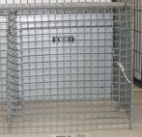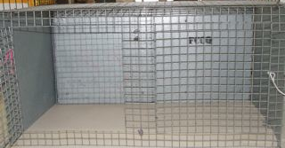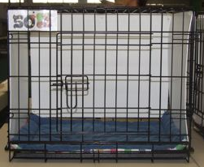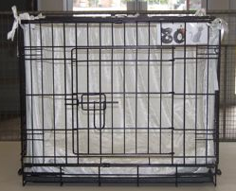

Where possible, requests for double cages will be accommodated. Should demand outstrip supply, cages will be allocated according to the breed/maturity of the exhibit. It is advisable to use adjustable curtains for this show. Curtains may be any colour but without any other decoration in the cage and no distinguishing marking such as names etc.

General Public Entry Prices
$5 Adults $10 Families

Show Raffles
There will be a big raffle table set up at the show with multi draw raffles going on throughout the day.

Important Things To Note

Before the show
- Please make sure you include a copy of each cat’s registration certificate/certified pedigree with your entry.
- If your cat has a title you must put it on the entry form.
- This is a four ring show over one day. Your cat will be handled at least four times. Please consider your cats temperament when entering!
- All exhibits must have front and rear claws clipped.
- Please take care completing your entry. Obviously incorrect or incomplete applications will be queried by reverse-charge phone call or email if provided. The show secretary will email or post you a confirmation of your entry. Check it carefully and reply with any changes as errors may result in your cat being disqualified or outclassed.
- Desexed and entire kittens will be shown in the same class.
- As per show rule 12 only one exhibitor pass will be given per owner so if you will be accompanied by other friends or family you may need to purchase another pass with your entry.
- Do not send original pedigree copies as these will not be returned.
- Entries will not be accepted for breeds or colours/patterns not accepted by ACF

At the show
- All exhibits must remain in their cages until the show closes.
- Please be aware of the closing time of the show. Any exhibit left in the hall unattended at the close of show will be removed and taken to one of the boarding catteries listed above overnight at the owner’s expense.
- Cat litter must be disposed of ONLY in the marked bins. Please don’t use the judges’ bins as the odour is unpleasant and will upset other exhibits. Failure to comply with this rule may result in your exhibit's results being withheld.
- No powders or sprays are to be used within the show hall unless in a designated grooming area.

Trade Stalls

If you would like a trade stall we would love to hear from you. Set up for your display or trade stall will be on Saturday from . Stalls are $50 each. Table Hire is $10 if you don’t have your own. Please complete the Trade Stall Booking Form below and attach this with your remittance and Schedule A Summary.
_____________________________________________________________________________________________________

Trade Stall Booking Form

Show Name: 39th Australian Cat Federation National Championship Cat Show
Show Date: 12^{h} June, 2011
Name:
Address:
Post Code:
Telephone:
Email (for details confirmation):

Please tick relevant box

❑ Please include my contact and stall information in the catalogue

❑ I have my own table/s

❑ I need  (please indicate number) hire table/s

Please provide brief description or details of products on display

____________________________________________________________________________

____________________________________________________________________________

____________________________________________________________________________

____________________________________________________________________________

____________________________________________________________________________

Catalogue Advertising

Advertising in the catalogue is also available. We are accepting business card sized adverts at $5.00 each. You can include the card with your entry and we will scan it or email an electronic copy to the show secretary. A full page is $20 and a half page is $15. Please complete the Advertising Copy Form and attach this with your remittance and Schedule A Summary. Contact the show secretary to discuss other catalogue advert sizes.

Advertising Copy Form
Show Name: 39th Australian Cat Federation National Championship Cat Show
Show Date: 12^{h} June 2011,
Name:
Address:
Post Code:
Telephone:
Email (for details confirmation):

______________________________________________________________________________________________

Size of Advertising needed:

Please tick relevant box

❑ $ 5.00 Business Card Size as attached

❑ $15.00 Half Page copy attached  will be emailed 

❑ $20.00 Full Page copy attached  will be emailed 

❑ Other as arranged with Show Secretary
Schedule A Show Summary Sheet
Show Name: 39th Australian Cat Federation National Championship Cat Show
Show Date: 12th June 2011,
Name:
Address:
 |  | Post Code:
Telephone:
Number of Exhibits: | Registration Body:
Email (for entry confirmation):
❑ Please tick here if you do not want your contact information to be printed in the catalogue
No. | Details | Price | Total | Please read and sign below to show your acceptance of these terms  I hereby certify that all particulars above, and on the entry forms herewith, are true and correct, that all exhibits are owned or leased by me and are eligible for classes entered, and are entered at my own risk. I agree to abide by the Show Rules and Regulations of the Australian Cat Federation Inc and to accept Show Officials' decisions. My exhibits have not been in contact with infectious/contagious diseases within 30 days prior to this show.  Signed (both required for joint entries, parent or guardian for exhibitors under 18 years)  Date
 | Entry fee for exhibit 4 rings | $45.00
1 | Vetting Fee Per Exhibitor | $5.00 | $5.00
1 | Benching Fee per Exhibitor | $5.00 | $5.00
 | Double Cage Fee (supplied by ACF) | $10.00
 | Single Exhibition Cage (supplied by ACF) | $5.00
 | Double Exhibition Cage (supplied by ACF) | $10.00
 | Catalogue | $15.00
 | Catalogue Advertising  Full Page $20, Half Page $15, Bus Card $5 | $.......
 | Additional Exhibitor Pass | $3.00
 | Stall | $50.00
 | Stall Table Hire | $10.00
Schedule A Total |  |  | $

ENTRY SUMMARY SHEET & VETTING SLIP – OWNER/S MUST COMPLETE DETAILS Please fill in relevant details

EXHIBITOR’S NAME *CATALOGUE: YES / NO (please circle)
NAME OF EXHIBIT/S | KITTEN, CAT, DESEXED  G1, G2, G3, G4, EXHIBITION | Please indicate below if need a single or double cage or if you are providing your own approved cage**  *S .. *D .*OS .. *OD |  |  |  | CAGE NO.
PLEASE ADVISE OF ANY ABSENTEES OR WITHDRAWN EXHIBITS WHEN COLLECTING YOUR SUMMARY SHEET ON ARRIVAL AT THE SHOW VENUE.
*S – Standard Single Cage *D – Standard Double Cage *OS – Owner Approved Single Cage *OD – Owner Approved Double Cage
** See above under “Cage Sizes and Curtains” for descriptions of Standard and Owner Approved Cages.
Please refer to Schedule B for weekend events and functions and complete remittance slip with your payment.
Entry Form
Please complete all details for each exhibit. Please note the cats pattern if it has one ie bicolour, colourpoint, tabby, tabby bicolour etc. For tabby cats please put “spotted tabby” “classic tabby” , “mackerel tabby” or “ticked tabby”
Please copy page should you have additional entries – electronic copy on show website in word format
Pedigree Exhibits Entry
Cat/Kitten Name:
Breed: |  | Sex: Male Female Neuter Spey
Reg No: |  | Date of Birth:
Colour & Pattern:
Sire Name:
Breed: | Colour & Pattern:
Dam Name:
Breed: | Colour & Pattern :
Breeder:
Pedigree Exhibits Entry
Cat/Kitten Name:
Breed: |  | Sex: Male Female Neuter Spey
Reg No: |  | Date of Birth:
Colour & Pattern:
Sire Name:
Breed: | Colour & Pattern:
Dam Name:
Breed: | Colour & Pattern :
Breeder:
Pedigree Exhibits Entry
Cat/Kitten Name:
Breed: |  | Sex: Male Female Neuter Spey
Reg No: |  | Date of Birth:
Colour & Pattern:
Sire Name:
Breed: | Colour & Pattern:
Dam Name:
Breed: | Colour & Pattern :
Breeder:
Companion Cat Entry
Cat/Kitten Name:
Colour/Pattern: | Sex: Male Female Neuter Spey
Date of Birth (estimate if unknown):
Companion Cat Entry
Cat/Kitten Name:
Colour/Pattern: | Sex: Male Female Neuter Spey
Date of Birth (estimate if unknown):

ACF National Show 2011 Volunteering
We are calling for registrations of interest from Exhibitors & family members who could assist with the smooth running of this event. The more people willing to lend a hand the less we all have to do and the more time everyone will get to see their cats judged and enjoy the show.

If you can help on or before show day please let the show manager know by completing this form and sending it with your entry.

Name

I can assist with

❒ Stewarding – I am a qualified steward

❒ Judges Scribe

❒ Runner (collecting paperwork from rings)

❒ Exhibitor or Judges Support – Accommodation, collecting from airport, etc

❒ Transport - mini bus driver, have large vehicle or truck to help move equipment

❒ Set up before show

❒ Pull down after show

❒ Any other area you think you could assist

SCHEDULE B

Australian Cat Federation Inc.
39th National Championship Show &
AGM
Weekend Events

Proudly hosted by

Queensland Independent Cat Council (Inc)

June 10th to 13th, 2011
Join us at

Brisbane International Virginia Palms Hotel
Cnr Sandgate & Zillmere Roads
BOONDALL, Queensland.
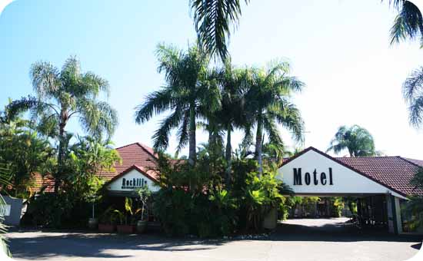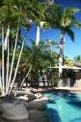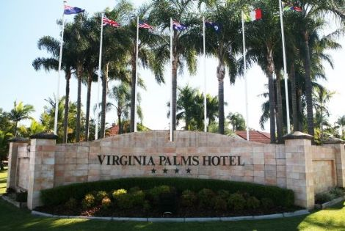

Events Timetable
Friday 10th June  2.30 pm | ACF Executive Meeting | Small Conference Room  Brisbane International Virginia Palms
Friday 10th June  7.00 pm | ACF Welcome Supper  Selection of Hot Savoury &  Savoury Platters | Small Conference Room  Brisbane International Virginia Palms
Saturday 11th June  8.45am - 12.30pm | ACF Judges Guild AGM  Morning Tea of Fruit & Buttermilk Scones with Whipped Cream & Strawberry Jam.  Freshly Brewed Coffee, Assorted Teas & Hot Chocolate | Small Conference Room  Brisbane International Virginia Palms
Saturday 11th June  12:45pm – 1:45pm | ACF Judges Guild AGM & Seminar Lunch  A Selection of Assorted Sandwiches & Turkish Bread  Sliced Seasonal Fresh Fruit Platter  Freshly Brewed Coffee, Assorted Teas, Hot Chocolate & Softdrinks | Small Conference Room  Brisbane International Virginia Palms
Saturday 11th June  2.00pm - 5.00pm | ACF Judges Guild Seminar  Visitors Welcome  Afternoon Tea of Individual Assorted Cheesecakes  Freshley Brewed Coffee, Assorted Teas & Hot Chocolate | Small Conference Room  Brisbane International Virginia Palms
Sunday 12th June  7.30pm for 8.00pm | ACF National Show Dinner  2 course Bar-B-Q Dinner Main & Desert  (Pre-paid bookings essential) | Large Conference Room  Brisbane International Virginia Palms
Monday 13th June  9.30am - 5.00pm | ACF Inc AGM  Morning Tea  Assorted Muffins.  Freshly Brewed Coffee, Assorted Teas & Hot Chocolate  Lunch  A Selection of Assorted Sandwiches & Turkish Bread  Sliced Seasonal Fresh Fruit Platter  Freshly Brewed Coffee, Assorted Teas, Hot Chocolate & Softdrinks  Afternoon Tea  Chocolate Eclairs  Freshly Brewed Coffee, Assorted Teas & Hot Chocolate  (Observers welcome) | Small Conference Room  Brisbane International Virginia Palms

ACF Judges Guild Seminar
TOPIC
Turkish Vans
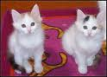
Presentation by Don Finger
& Julie Walker
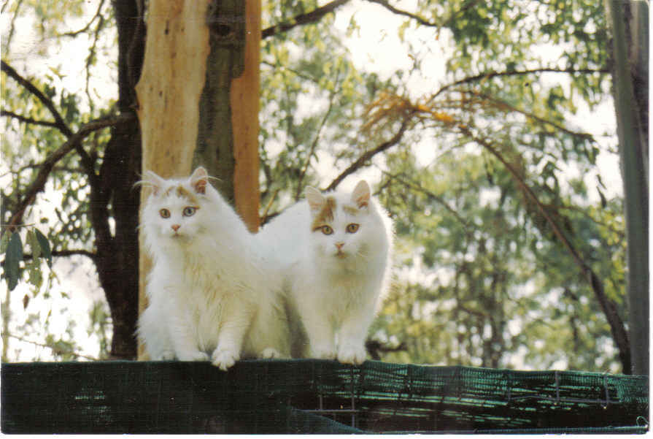
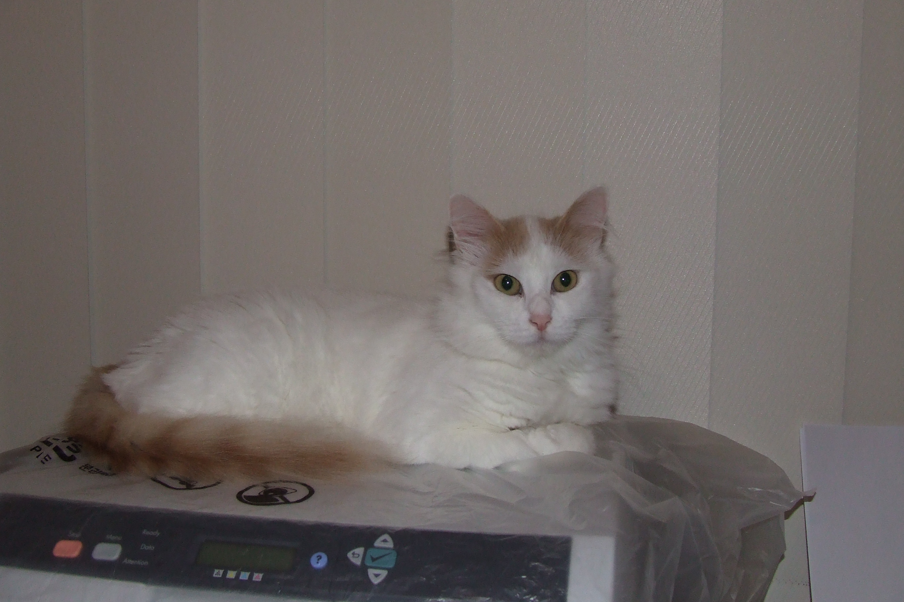

Tonkinese  Presentation by  Aline Noel | 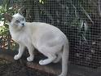  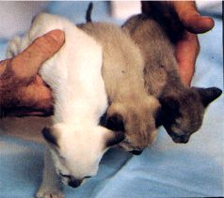  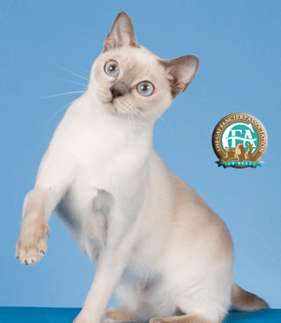
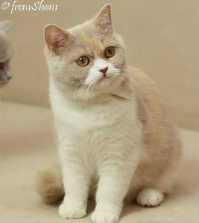
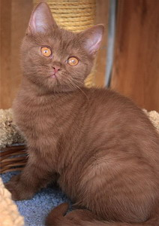
British Shorthair
New Colours & Patterns

Presentation by Monika Dany
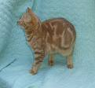
Fawn Tortie & White Cinnamon

Cinnamon Classic Tabby
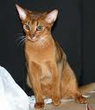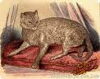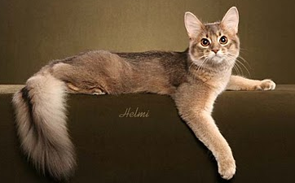 |  | Abyssinians & Somalis  Presentation by Yukiko Hayata
Bengals
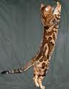
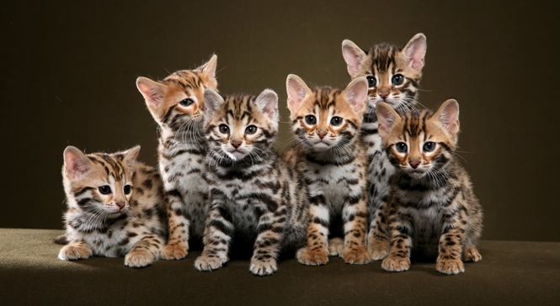
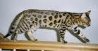

Presentation by Carlos Lopez

ACF National Show Dinner
2 course Bar-B-Q Style Buffet Dinner
Main & Dessert
Menu

Main Course

Tender Rib Fillet

Pork & Beef Sausages

Chicken Satays

Onion Rings

Idaho Potato

Freshly Baked Bread Rolls

Tossed Salad

Coleslaw

Pasta Salad

Dessert

Pavlova
served with fruit salad & cream

Freshly Brewed Coffee & Assorted Teas
served with Dinner Mints
BBQ Menus

Schedule B Function Summary Sheet
Name/s:

Address:

 |  |  | Post Code:
Telephone: |  | Email:
No. | Details |  | Price | Total
 | FRI: Welcome Supper |  | $30.00
 | SAT: Judges’ Guild Morning Tea |  | $7.00
 | SAT: Judges’ Guild Lunch |  | $16.00
 | SAT: Judges’ Guild Afternoon Tea |  | $7.00
 | SAT: Judges’ Guild Optional All Day Tea/Coffee |  | $3.50
 | SUN: Official Show Dinner |  | $45.00
 | MON: ACF AGM Morning Tea |  | $7.00
 | MON: ACF AGM Lunch |  | $16.00
 | MON: ACF AGM Afternoon Tea |  | $7.00
 | MON: ACF AGM Optional All Day Tea/Coffee |  | $3.50
Schedule B Total |  |  |  | $
Please refer to Schedule A for ACF National Show Entries and Summary Sheet and complete remittance slip with your payment.
Please complete the details of the functions/events you wish to attend on the Ticket forms below and these will be returned to you as your official ticket, giving you entry to the events you nominate.

Australian Cat Federation Inc.39th National Championship Show &
AGM Weekend Events
MULTI EVENT TICKET NUMBER: …………………………...

Name of Attendee: ………………………………………………………...
(Please write your name here)
DATE | FUNCTION | (Please tick Box)
Friday 10th June, 2011 | Welcome Supper
Saturday 11th June, 2011 | Judges’ Guild AGM Morning Tea
 | Judges’ Guild AGM & Seminar Lunch
 | Judges’ Guild Seminar Afternoon Tea
 | Optional All Day Tea/Coffee
Sunday 12th June, 2011 | Official Show Dinner
Monday 13th June, 2011 | ACF AGM Morning Tea
 | ACF AGM Lunch
 | ACF AGM Afternoon Tea
 | Optional All Day Tea/Coffee

Australian Cat Federation Inc.39th National Championship Show &
AGM Weekend Events

MULTI EVENT TICKET NUMBER: …………………………...

Name of Attendee: …………………………………………………………...
(Please write your name here)
DATE | FUNCTION | (Please tick Box)
Friday 10th June, 2011 | Welcome Supper
Saturday 11th June, 2011 | Judges’ Guild AGM Morning Tea
 | Judges’ Guild AGM & Seminar Lunch
 | Judges’ Guild Seminar Afternoon Tea
 | Optional All Day Tea/Coffee
Sunday 12th June, 2011 | Official Show Dinner
Monday 13th June, 2011 | ACF AGM Morning Tea
 | ACF AGM Lunch
 | ACF AGM Afternoon Tea
 | Optional All Day Tea/Coffee

Australian Cat Federation Inc.39th National Championship Show &
AGM Weekend Events
MULTI EVENT TICKET NUMBER: …………………………...

Name of Attendee: …………………………………………………………...
(Please write your name here)
DATE | FUNCTION | (Please tick Box)
Friday 10th June, 2011 | Welcome Supper
Saturday 11th June, 2011 | Judges’ Guild AGM Morning Tea
 | Judges’ Guild AGM & Seminar Lunch
 | Judges’ Guild Seminar Afternoon Tea
 | Optional All Day Tea/Coffee
Sunday 12th June, 2011 | Official Show Dinner
Monday 13th June, 2011 | ACF AGM Morning Tea
 | ACF AGM Lunch
 | ACF AGM Afternoon Tea
 | Optional All Day Tea/Coffee
Australian Cat Federation Inc.
39th National Championship Show &AGM
Weekend Events

Remittance Slip
Name:

Address:

 |  |  | Post Code:
Telephone: |  |  | Email:
Sub Total Schedule A (Show Entries, Catalogue, Stalls, Advertising, Exhibitor Passes) |  |  |  | $
Sub Total Schedule B (Functions and Events, including Official Dinner) |  |  |  | $
ACF Year Book/s |  |  | No: | $
Rozette Sponsoreship (Please fill out Rosette Sponsorship form included with the Additional Information) |  |  |  | $
Donation |  |  |  | $
Total Due
(Office Use Only) | Receipt Number:
Please note that Schedule A and Schedule B need to be completed separately and submitted with your Remittance.

Please make your Cheque/money order payable to
Queensland Independent Cat Council (Inc) National Show 2011– Do not send cash

Australian Cat Federation Inc.
39th National Championship Show &
AGM
Weekend Events

Proudly hosted by

Queensland Independent Cat Council (Inc)

Exhibitor and Visitor
Additional Information

Contact Information

Transport

Accommodation

Boarding Facilities

Ribbon Sponsorship

Contact Information

Contact for general queries: Show Manager/Secretary –
Julie Walker (07 5496 0331)
Vanstar1@bigpond.com

Post applications to: 430 Steve Irwin Way
BEERBURRUM, Qld 4517

Make cheques payable to: Queensland Independent Cat Council Inc. National Show 2011

Transport



The show committee are negotiating with Hertz Car Rental a special rate for car hire for exhibitors travelling to Brisbane from outside of Brisbane and interstate.

Our mini bus service has also been provided by Hertz Car Rental. Please advise the show manager if you require transport from or to the airport/and or the show.

Accommodation
The Show Committee has negotiated some ‘Cat Friendly’ accommodation at Brisbane International Virginia Palms, Carseldine Court Motel and Bald Hills Motel. Please be considerate and clean – do not spoil this privilege for everyone else.
BRISBANE INTERNATIONAL  VIRGINIA PALMS  Cats Allowed  Corner Sandgate & Zillmere Roads, Boondall Qld 4034  Telephone: 07 3265 7066 Fax: 07 3865 1735  www.palmsinternational.com.au  Conveniently located less than ten minutes from the show venue and twenty minutes from Brisbane Airport. Also the venue for all functions, including the Show Dinner.  General room features  - Hairdryer  - Iron & Ironing Board  - Tea & Coffee Making Facilities  - Mini Bar (in most rooms)  - Desk  - Telephone  - Broadband Internet Acess  - Airconditioning  - TV with local stations & free Foxtel channels  - Room Service (Breakfast & Dinner) | Delux Room (Single/Double/Twin)  Each of our Single/Double Delux Suites feature a Queen Size bed. The Twin Delux Suites feature a Queen Size bed plus a Single Bed.  Single / Double @ $160.00 per room per night  Twin Share @$170.00 per room per night  For pricing on the two bedroom fully self-contained villas and two bedroom apartments, please contact the Hotel direct.  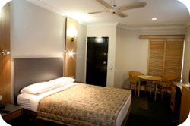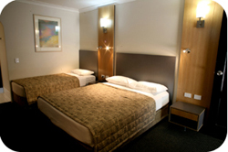  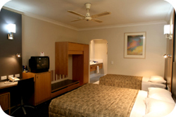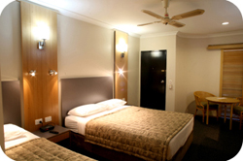

Located only five minutes from show and function venues
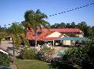 Carseldine Motel Grounds
Cats Allowed
1549 Gympie Road
CARSELDINE, Qld 4034
Phone: (07) 3263 5988 Fax: (07) 3862 9744
Email: info@carseldinecourt.com.au
Carseldine Court Motel provides quality, affordable accommodation for the travelling public. Recently refurbished and new rooms ensure modern facilities and decor. *Note ~ All rooms are strictly Non smoking!  Nightly tariffs starting at $99 per room. Weekly tariffs are available.  Taxi fare from Brisbane Airport to the motel is approximately AU$45. |  |  | 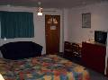  Deluxe Standard Room  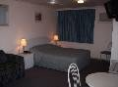  Standard Double Room
Cancellation Policy  **Note: Our cancellation policy is one that guarantees the booking & full payment thereof. Should a cancellation occur for any unforeseen reason prior to the date yet outside of 48 hours from the due date of arrival an administration fee of $20.00 per room shall be deducted as a cost for administration & services rendered. Should a cancellation be made & fall within the 48 hour period prior to the arrival date then the full amount of the booking will be forfeited. |  | Group Bookings and Coach Parties  We are able to accommodate & cater for coach parties large groups & sporting fraternities having ample parking for busses and the like.  Carseldine Court Motel is approximately 12 kilometres north of the Brisbane GPO, convenient to major highways, shopping centres and other facilities. Public transport is available within 100 metres. The Gold Coast and Sunshine Coast are within a 40 kilometre radius.  Our friendly staff are always available to help out when needed.
At both Virginia Palms and Carseldine Court Motel cats will be allowed in the rooms, however they must be in cages and kept in the bathroom area. Under no circumstances are they allowed on the beds or on any carpeted area. If any cat hair is found in the room there will be a $100.00 cleaning fee charged to the guest staying in the room.

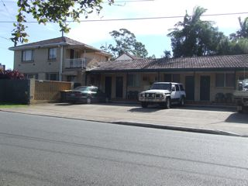

Bald Hills Motel
Cats Allowed
1969 Gympie Road
(Cnr Telegraph Road)
BALD HILLS, QLD
Phone: (07) 3261 1618 Fax: (07) 3261 2019

Price: From $99 Double Room/Night
(Plus $10 Cleaning Fee for allowing cats in rooms)

Bald Hills Motel Overview
Located less than five minutes from the show venue at Bald Hills Primary School, ten minutes from Virginia Palms and less than 30 minutes from Brisbane Airport, Bald Hills Motel is a small quiet motel with only six rooms providing basic comfortable facilities and a friendly personalized service.
Bald Hills Motel Features & Facilities  - Customer Carpark  - BBQ Area  - Laundry | 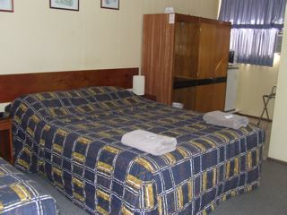  Room Features & Facilities  - Air Conditioning  - Television  - Radio/CD Player  - Refrigerator  - Tea/Coffee Facilities
794 Zillmere Road
Aspley 4034
Phone: (07) 3263 6122
Fax: (07) 3263 6714

(Only five minutes from Show Venue)


Cats Not Allowed
  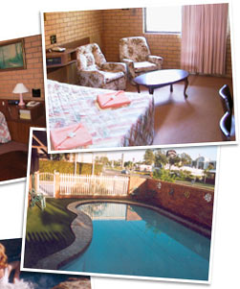 |  | Room Features  • All ground floor units, family suites available  • Foxtel  • Queen size beds  • Tea/Coffee making facilities  • Air conditioned  • Hairdryers  • Internet access  Guest Facilities  • Private pool and spa  • Shaded barbeque area  • Comprehensive breakfast menu  Your friendly hosts - Lewis and Maureen Hall.
Boarding

Cat Boarding for exhibitors who arrange alternative accommodation where cats are not accepted the following catteries are able to board your cats. The cats will be delivered to the Show venue each morning and picked up each afternoon. Please contact the catteries direct for bookings and costs.

239 Norris Road
Bracken Ridge QLD, 4017
(07) 3261 1212

www.allbreedspetmotel.com.au



All Breeds Pet Motel aims is to make your dogs and cats as comfortable as possible with Deb and Greg Beilby, creating a 'home away from home' environment. Dogs are housed in large airy runs, with kennels adjoining grassed exercise yards where your furry friend can work off their excess energy. Exercise is provided at no extra charge, as well as lots of cuddles and attention. The kennels are kept in a very clean and tidy condition, with each pet sleeping on a raised trampoline bed. Hydrobaths are also available, complimentary for longer staying guests. Royal Canin is the premium dry food we supply and special diets can be catered for.

Our feline friends are also especially catered for, being housed in a large, airy and secure environment. Puss will be housed in a roomy, individual, walk-in unit, with cosy cubbies provided. There is also a separate outdoor area where cats can have their daily stroll or simply relax in the sun. They will enjoy an exceptionally clean environment in a quiet location.

This boarding facility is Government registered and a member of the Pet Boarding & Grooming Association.

Cattery  Secure facilities.  Cats are allowed the freedom to wander the entire cattery (at the owner's discretion).  Roomy individual walk-in units measuring 1820H x 1150D x 830W.  Royal Canin dry food will be your cat’s diet.  Varied menu with 4 choices everyday.  Lots of pampering at no extra cost.  Quiet location.  Exceptionally clean.  Medication administered and special diets prepared.  Please let us know if your pet has any special dietary requirements or unusual behaviour. Your pet may bring something from home such as a toy or blanket, however we cannot guarantee its return or condition. | 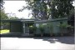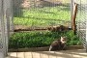  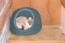

Payment Methods Accepted: Mastercard - Visa - Cash - EFTPOS

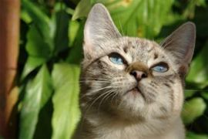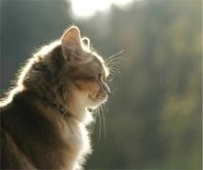 | Brisbane Pet Motel  Specialists in Pet Care  2290 Sandgate Road - Boondall QLD 4034  Phone 07 3265 2492- Fax 07 3865 3471  email paul@bpet.com.au & leanne@bpet.com.au
Dog and Cat Boarding and Pet Transport  Brisbane Pet Motel is situated on 2.5 acres at Boondall in the northern suburbs of Brisbane. This is less than 20 minutes from the Brisbane airport, with easy access to and from the Gateway Motorway heading to the Sunshine Coast, Gold Coast and Toowoomba.  While your pets are in our care they will receive professional attention, be entertained by 24 hour piped music, and enjoy spacious and hygienic accommodation. We are very happy to discuss any special requests you may have.  The Owner / Managers are onsite 24 hours a day, and they, along with our dedicated Kennel and Cattery Staff, provide 24 hour security for the pets boarding with us. We also utilise sensors and monitoring devices throughout the facility.  We offer a Pick Up and Delivery Service for our four legged guests, as well as Transport Services if your pet is travelling interstate or overseas. We also have transport crates for hire or purchase. |  | 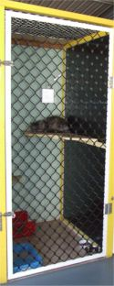

Allbreeds Pet Motel
Brisbane Pet Motel
2011 ACF National Show Rosette Sponsorship

The 2011 ACF National Cat Show for pedigreed and domestic cats will be held in Brisbane on 12th of June. The show will be held at the Toombul Indoor Sports Centre, 137 Bage Street, Nundah, and showcase the best cats in the country.
There will be over four hundred awarded at the show for the top ten entire cats, kittens and desexed cats over three groups plus awards for the top ten companion cats. We would like to invite your sponsorship of place rosettes for the show.

Sponsorship Options

1. Sponsorship of top ten in section $65
Example - Top ten group one kittens
2. Sponsorship of Group $200
Example - All of group three in ring one
3. Sponsorship of Ring $600
Example - Top ten kitten, desexed and adults in group one, two, three and companions in one ring

Name

Address

Phone Number

Email

Sponsor name to appear in Catalogue (name, cattery name, business name etc)

I would like to sponsor
Option | Preferred Section/Group  ie 2 x G3 adults | Total
1. Sponsorship of top ten in section $65
2. Sponsorship of Group $200

3. Sponsorship of Ring $600

 | Total Sponsorship

Please send this form with your remittance slip and payment made out to Queensland Independent Cat Council (Inc) National Show 2011 to
Rosette Sponsorship:
Address

