BEST LONGHAIR EXHIBITS 2017 | BREED | BREEDER | OWNER
BEST LONGHAIR KITTEN
FIDELIS FIRE N ICE | MAINE COON | T LAMB | T LAMB
RESERVE LONGHAIR KITTEN
TIPASHEENA JADZIA DAX | RAGDOLL | J&R CLARKE | J&R CLARKE
BEST LONGHAIR CAT
UK CH SDGC COONFLAKES  IN A BROKEN DREAM (IMP UK) | MAINE COON | S&L WHITMARSH | T LAMB
RESERVE LONGHAIR CAT
GDGC KELANROWE MAXIMILIAN | RAGDOLL | K ROWE | R&J CLARKE
BEST LONGHAIR ALTER
XOXO KISMET HUGS | RAGDOLL | D WILSON | K PETRI
RESERVE LONGHAIR ALTER
BRZ AOE, QICC DDGC, GDGC PUSSYFOOT CRÈME DE LA CRÈME | PERSIAN | A SWIFTE | F COOMBS
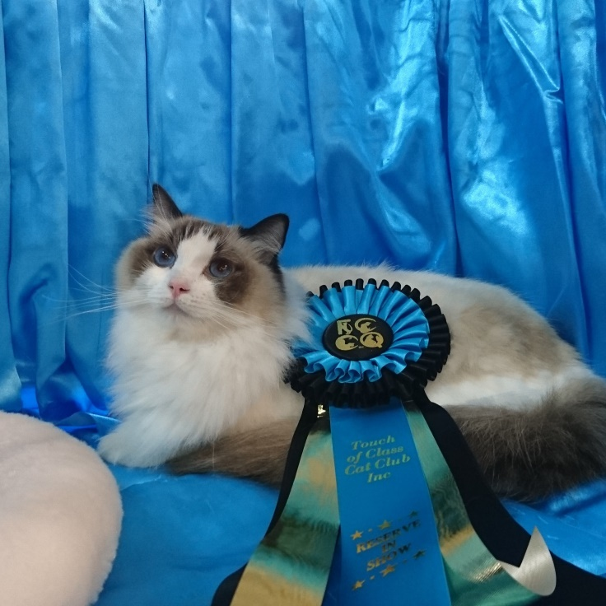 | XOXO KISMET HUGS

